**NAME:** VINCENT MARUGE KANGE’THE

**INDEX NUMBER:** 11211301226

**NAME OF THE SCHOOL:** NGENIA HIGH SCHOOL

**YEAR OF EXAMINTION:** 2019

**SUBMITTED TO:** KENYA NATIONAL EXAMINATION COUNCIL

# ACKNOWLEDGEMENT

I would like to give thanks my mum ,dad brothet ,sister and nephew malik for the support they provided in guiding and providing necessary requirements for the successful development of the electoral system .It was an honor working with you to give the best.

# DEDICATION

Special dedication to Mary Githiu, Viviane Wangari and to all those in charge of the electoral body in Rehema School.

# ABBREVIOATIONS

# ADMN -admission number Table of contents

Contents

ACKNOWLEDGEMENT i

DEDICATION ii

ABBREVIOATIONS iii

ADMN -admission number Table of contents iii

Table of contents iv

LIST OF TABLE vii

LIST OF FIGURES viii

CHAPTER 1 1

1.0 INTRODUCTION 1

CHAPTER TWO 3

2.1 PROBLEM ANALYSIS 3

2.2 OVERVIEW OF THE EXISTING SYSTEM 4

2.2.1 ADVANTAGES OF THE EXISTING SYSTEM 4

2.2.2DISADVANTAGES OF THE EXISTING SYSTEM 4

2.3 OVERVIEW OF THE PROPOSED SYSTEM 4

2.3.1 BENEFITS OF THE PROPOSED SYSTEM 5

2.4 OBJECTIVES OF THE PROPOSED SYSTEM 5

2.5 SCOPE OF THE SYSTEM 5

2.6 FEASIBILITY 5

2.7 FACT FINDING 7

2.7.1 QUESTIONNAIRE 7

2.7.2 Interview 8

2.7.3 OBSERVATION 9

CHAPTER THREE 10

3.0 REQUIREMENTS SPECIFICATION 10

3.1 OUTPUT SPECIFICATION 10

3.2 INPUT SPECIFICATION 10

3.3 FILE /DATA STORES 11

3.4 HARDWARE AND SOFTWARE REQUIREMENT 11

CHAPTER FOUR 12

4.0 SYSTEM DESIGN 12

4.1 REHEMA SCHOOL PREFECTS ELECTORAL SYSTEM FLOW CHART 12

4.2 MODULE FLOW CHART 15

4.2.1 REGISTRATION MODULE FLOW CHART 15

4.2.2 CLASS LEVEL VIEING MODULE FLOW CHART 16

4.4.3 FORM LEVEL VIENG MODULE FLOW CHART 17

4.2.4 SCHOOL LEVEL VIENG MODULE FLOW CHART 18

4.2.5 CLASS LEVEL VOTING MODULE FLOW CHART 19

4.2.6 FORM LEVEL VOTING MODULE FLOW CHART 20

4.2.7 SCHOOL LEVEL VOTING MODULE FLOWCHART 21

4.3 INPUT DESIGN 22

4.4 STORAGE DESIGN 28

Table 8:4.4.5 electoral position 4.5 OUTPUT DESIGN 30

4.5 OUTPUT DESIGN 31

CHAPTER FIVE 38

5.0 SYSTEM CONSTRUCTION 38

5.1 INPUT SCREENS 38

figure 26.5.1.1 contestant form 38

5.2 TABLE DESIGN 42

5.3 QUERY DESIGN 46

5.4 REPORT DESIGN 52

5.5 RELATIONSHIP DESIGN 55

CHAPTER SIX 56

6.0 SYSTEM TESTING AND IMPLEMENTATION 56

6.1SYSTEM TESTING 56

6.2 OBJECTIVE OF TESTING 57

6.3SYSTEM IMPLEMENTATION 57

6.3.1File conversion 57

6.3.2Staff training 57

6.3.3Changeover strategies 58

6.4 SYSTEM SECURITY AND CONYROL MEASURES 58

CHAPTER SEVEN 59

7.0SYSTEM REVIEW AND MAINTENANCE 59

7.1Rehema School Prefects Electoral System user manual 59

7.1.1The Installation requirements 59

7.1.2Steps of installation 59

How to run the application program 60

7.1.3Adding a new voter 61

7.1.4Searching a voter 62

7.1.5 Deleting a voter 62

7.1.6Steps on generating outputs 63

7.1.7Ending the program 63

7.2Recommendations 64

7.3Conclusion 64

7.4 Bibliography 64

7.5APPENDICES 65

7.5.1Appendix 1 65

7.5.2Appendix 2 65

# LIST OF TABLE

Table 1:3.4.1 hardware specification 11

Table 2:3.4.2 software specification 11

Table 3:4.4.1 voters table 28

Table 4:4.4.2 class teachers table 28

Table 5:4.4.3 class table 29

Table 6:4.4.6 stream table 29

Table 7:4.4 contestant table 30

Table 8:4.4.5 electoral position 30

Table 9.7.5.1 diagrams used in the system 65

# LIST OF FIGURES

figure 1:2.6.1 schedule feasibilty 6

figure 2:2.7.1 sample questionnaire 7

figure 3:2.7.3 sample interview 9

Figure 4:4.1.1 system flow chart 14

figure 5:4.2.1 registration module flowchart 15

figure 6:4.2.2 class level vieing module flow chart 16

Figure 7:4.2.3 form level vieing module flowchart 17

Figure 8:4.24 school level vieing module flow chart 18

figure 9:4.2.5 class level voting module flowchart 19

Figure 10:4.2.6 form level voting module flowchart 20

figure 11:4.2.7 school level voting module flow chart 21

Figure 12:4.3.1 voters registration form 22

figure 13:4.3.2 class teachers form 23

Figure 14:4.3.3 class form 24

Figure 15:4.3.4 contestant form 25

figure 16:4.3.5 electoral position form 26

Figure 17:4.3.6 stream form 27

figure 18:4.5.1 form 1 north voters list 31

Figure 19:4.5.2 form 4 north voters list 32

figure 20:4.5.3 form level contestant list 33

Figure 21:4.5.4 class level contestant list 33

figure 22:4.5.5 class teachers list 34

Figure 23:4.5.6 winners list 35

figure 24:4.5.7 list of spoilt votes 36

Figure 25:4.5.8 contestant list and votes garnered 37

figure 26.5.1.1 contestant form 38

Figure 27.5.1.2class form 39

figure 28.5.1.3 electoral post form 39

Figure 29.5.1.4 form for streams 40

figure 30.5.1.5results form 40

Figure 31.5.1.6 teachers form 41

figure 32.5.1.7 voters registration form 41

Figure 33.5.2.1 table class 42

figure 34.5.2.2table contestant 42

Figure 35.5.2.3 table class teacher 43

figure 36.5.2.4 table stream 43

Figure 37.5.2.5 table voters 44

figure 38.5.2.6 table electoral post 44

Figure 39.5.2.7 table results 45

figure 40.5.3.1 Query contestant and votes garnered 46

Figure 41.5.3.2 Query class prefect 47

figure 42.5.3.3 Query votes garnered for each contestant 48

Figure 43.5.3.4 Query class teachers 49

figure 44.5.3.5 Query form captain 50

Figure 45.5.3.6 Query library captain 51

figure 46.5.4.1 REPORT FOR VOTES GARNERED FOR EACH CONTESTANT 52

Figure 47.5.4.2 REPORT FOR FORM CAPTAIN 52

figure 48.5.4.3 VOTERS 53

Figure 49.5.4.4 DH CAPTAIN 53

figure 50.5.4.5 CLASS TEACHERS 54

Figure 51.5.4.6 CLASS PREFECT 54

figure 52.5.5.1 RELATIONSHIPS 55

figure 53.6.1.1using test data method 56

Figure 54.7.1.1the appearance of the sytem when loaded 60

figure 55.7.1.2 1adding a new voter 61

Figure 56.7.1.3 searching for a voter 62

figure 57.7.1.4deleting a voter 63

# CHAPTER 1

## 1.0 INTRODUCTION

Rehema school is a day secondary school with five streams each in form one ,form two ,form three and form four.The students ‘ administrative structure is in three levels ; school level ,form level and class level. The school level student’s leadership positions comprise of the head boy, the head girl, dining hall captain, games captain and the library captain. The form level positions comprise of form captains who are in charge of all the streams in their respective forms.The class level positions comprise of the class prefects who are in charge of their classes and are answerable to their respective form captains .All the positions are elective and the holders serve for a one year term.

The school’s elections are held at the beginning of each year .only form three students are eligible for school level positions. The school level prefects are elected by all the students in the school. A form level captain is elected by all the students in the streams his/her own form. A class prefect is elected by members of his/her own class.

Those students who intend to vie for the positions are required to be vetted by the school administration .The successful candidates are required to provide their personal details which would be used in the ballot papers .The school level and the form level contestants are vetted by the school administration , while the class level contestants are vetted by their respective class teachers .one of th requirements in the vetting is that each contestant must have been proposed and seconded by their electorate. Those seeking school level positions are required to be seconded by a student from each class in their respective forms. Those seeking class level positions are required to be seconded by two students from their respective classes.

Elections are carried out in every classroom concurrently, where the respective class teacher presides over the exercise. On the day of the elections, the class teachers collect ballot papers for each of the elective positions for their respective classes. During the polling, students are required to indicate their preference in the ballot papers by placing a tick (√) alongside the candidate of their choice and inserting the ballot papers in their respective ballot boxes.

Counting of votes is carried out in the respective classes and the results are recorded, announced and taken to the tallying centre .at the tallying centre, the form level and the school level vote results from the classes are combined and the total votes for each candidate recorded.

The candidate with the highest number of votes for each post is registered as the winner. The results of the election are forwarded to the school’s principal who then approves and announces the final results.

Develop a well documented computerized prefect’s election system that will:

1. Maintain
2. Records of classes and their respective class teachers;
3. List of contestants for each post;
4. List of electoral position;
5. List of students per class;
6. List of proposers and seconders;
7. Results for each level.
8. Compute
9. Total votes for each contestant at :

* School level
* Form level

1. The winner for each post ;
2. Determine the contestants with adequate proposers and seconders.
3. Generate the following reports
4. Voters list;
5. List of contestants for each post;
6. List of class teachers ;
7. List of winners for each post;
8. List of spoilt votes for each class;
9. List of contestants and the votes garnered.

# CHAPTER TWO

## 2.1 PROBLEM ANALYSIS

The problem at hand is to develop a computerized system that would maintain records of classes and their respective class teachers, list of contestants for each post, list of electoral positions, list of students per class, list of proposers and seconders and results for each level. The system will also compute total votes for each contestant at school level and form level, compute the winner for each post and determine the contestants with adequate proposers and seconders.

## 2.2 OVERVIEW OF THE EXISTING SYSTEM

The current system in operation in Rehema school electoral system is manual voting system where those students who intend to vie for positions are vetted by the school administration. The successful candidates are required to provide their personal details which would be used in the ballot papers. The school level and the form level contestants are vetted by the school administration, while the class level contestants are vetted by their respective class teachers. Elections are carried out in every classroom concurrently, where the respective class teacher presides over the exercise. On the Election Day, the class teacher collects ballot papers for each of the elective positions for their respective classes. During the polling, students are required to indicate their preference in the ballot papers by placing a tick ( √) alongside the candidate of their choice and inserting the ballot papers in their respective ballot boxes. Counting of votes is carried out in the respective classes and the results are recorded, announced and taken to the tallying centre ,the form level and the school level vote results from the classes are combined and the total votes for each candidate recorded. The candidate with the highest number of votes for each post is registered as the winner. The results are forwarded to the school’s principal who then approves and announces the final results.

### 2.2.1 ADVANTAGES OF THE EXISTING SYSTEM

1. It is cheap because it only requires papers rather than electronic gadgets such as computers.
2. It doesn’t require electric power to operate.

### 2.2.2DISADVANTAGES OF THE EXISTING SYSTEM

1. Preparing of ballot papers can be tiring
2. Time wastage when preparing ballot papers for all registered voters.
3. Misleading results due to poor data entries and organization.
4. Counting of votes may not be accurate as human’s are not 100% accurate.
5. Loss of data due to poor handling and organization.

## 2.3 OVERVIEW OF THE PROPOSED SYSTEM

The proposed system in Rehema school electoral system is computerized electoral system that will maintain records of classes and their respective class teacher ,list of contestants for each post, list of electoral positions, list of students per class, list of proposers and seconders and results for each level. The system will also compute total votes for each contestants at school level and form level, compute the winner for each post and determine the contestants with adequate proposers and seconders.

The system will also generate reports on voters list, list of contestants for each post, list of class teachers, list of winners for each post, list of spoilt votes from each class and list of contestants and the votes garnered.

### 2.3.1 BENEFITS OF THE PROPOSED SYSTEM

1. It requires minimal office space since only a computer is required.
2. The process of tallying is faster since calculations are done by computers.
3. Saves on time wasted when preparing ballot papers manually.
4. Accurate results are produced since computers are more accurate than humans.
5. Data is safe since multiple copies can be created and backed up.

## 2.4 OBJECTIVES OF THE PROPOSED SYSTEM

The objectives of the proposed system are:

1. To generate reports of voters list
2. To generate reports of list of contestants for each post
3. To generate reports of list of class teachers
4. To generate reports of list of winners for each post
5. To generate reports of list of spoilt votes from each class
6. To generate reports of list of contestants and the votes garnered.

## 2.5 SCOPE OF THE SYSTEM

1. The proposed system will compute total votes for each contestant at school level and form level
2. The proposed system will generate reports of voters list.
3. The proposed system will maintain records of classes and their respective class teacher.

## 2.6 FEASIBILITY

1. **OPERATIONAL FEASIBILITY**

The proposed system users are happy with the proposal to develop the new system.

1. **TECHNICAL FEASIBILTY**

The technology required to develop the proposed system is readily available in the market .The technology is Microsoft office.

1. **SCHEDULE FEASIBILITY**

|  |  |  |  |  |  |  |  |
| --- | --- | --- | --- | --- | --- | --- | --- |
|  | January | February | march | April | may | June | July |
| Problem recognition and definition |  |  |  |  |  |  |  |
| Information gathering |  |  |  |  |  |  |  |
| Requirement specification |  |  |  |  |  |  |  |
| System design |  |  |  |  |  |  |  |
| System construction |  |  |  |  |  |  |  |
| System implementation |  |  |  |  |  |  |  |
| System review and maintenance |  |  |  |  |  |  |  |

figure 1:2.6.1 schedule feasibilty

The proposed system will take 7 months.

1. **ECONOMIC FEASIBILTY**
2. **Costs**
3. Development kshs 40 000 000.
4. Monthly operational costs kshs 4 000 000.
5. Total life time of system 15 years .

Total lifetime costs kshs 40 000 000 +(12*4 000 000)*15=kshs 760 000 000.

1. **Benefits**
2. Savings on stationary used kshs 100 000
3. Savings on labour kshs 500 000
4. Savings from transport to buy stationaries kshs 550 000 000

Total monthly benefits kshs 550600000

Total lifetime benefits kshs (550600000*12*15)=kshs 99108000000

**Conclusion**

The development of the new system is cost effective and beneficial to Rehema prefect’s electoral system because lifetime benefits greatly outweigh the costs.

## 2.7 FACT FINDING

I gathered data using the following methods.

### 2.7.1 QUESTIONNAIRE

**REHEMA SCHOOL PREFECTS ELECTORAL SYSTEM**

Date 7/2/19

**Introduction**. Rehema School is in the process of developing a new computerized system.

Please, take a few minutes to fill in this questionnaire and return it to Rehema School before date 14-2-2019

Q1. How long does the registration of new voters take?

10 mins 5 mins 2 mins 1 mins

Q2. At what percentage accuracy are the resulst before they are announced?

50% 100% 99% 80%

Q3.how long does the process of tallying take at the tallying centre?

1 hour 2hours 30minutes 10 minutes

figure 2:2.7.1 sample questionnaire

### 2.7.2 Interview

|  |  |  |
| --- | --- | --- |
| Interviewee name: interviewer:  Date :  Time :  Place:  Subject: | | |
| Time allocated | Interviewer questions or objective | Interviewee response |
| 1 to 3 min | Objective  Good morning Mr. .Billy I am eng .Vincent  Thank you for your valuable time.  The purpose of this interview is to obtain information of the current system in Rehema. |  |
| 5 min | Question 1  What requirements must the students have to be registered as a voter?  Follow up |  |
| 3 min | Question 2  What action is taken when a student lacks his name in the list of registered voters?  Follow up |  |
| 4 min | Question 3  What steps are followed when registering a voter?  Follow up |  |
| 5 min | Question 4  Who are the individuals incharge of presiding over the voting and tallying process?  Follow up |  |
| 3 min | Question 5  What challenges are encountered during registration of voters? |  |
| 2 min | Objective  Thank you Mr. Billy for your co-operation.  I assure you that you will receive a copy of what transpired during the interview |  |
| 20 min | Time allotted for base questions and objectives |  |
| 9 min | Time allotted for follow up questions and redirection |  |
| 30 min | Total time allotted for interview(9:00 am to 10:30 am) |  |

figure 3:2.7.3 sample interview

### 2.7.3 OBSERVATION

1. I observed that the registration of voter is done manually by filling in forms and lists.
2. I observed that during voting students or registered voters are issued with a form containing a list of contestants where they put a mark or a tick on the contestants of their preference.
3. I observed that those who are viewing are issued with a form in which they fill in their details and then they personally hand over the form to the teachers in charge.
4. I observed that vetting of qualified contestants is done by teachers.
5. I observed that the voting process takes place in the classrooms and tallying is presided by class teachers then the results are taken to the tallying centre.

# CHAPTER THREE

## 3.0 REQUIREMENTS SPECIFICATION

## 3.1 OUTPUT SPECIFICATION

The system will generate the following reports

1. Voters list
2. List of class teachers
3. List of classes
4. List of contestants for each post
5. List of electoral positions
6. List of contestants and the votes garnered

## 3.2 INPUT SPECIFICATION

1. **Voter**

* Admission number PK
* Full name
* Form/ class
* Gender
* Stream

1. **Class teacher**

* Full name
* Gender
* Class/form
* TSC number PK

1. **Class**

* Class number PK
* Class name
* No. of students

1. **Contestants**

* Name PK
* Post
* Class
* Gender
* Stream

1. **Electoral position**

* Post PK
* Level
* Gender

1. **Stream**

* Name of stream PK
* No of stream

## 3.3 FILE /DATA STORES

**FILE /DATA BASES**

The main database file will be Rehema school prefects electoral system

**TABLE /RELATIONS**

This type of data structure will be used to store some of the data elements of various entities in the records.

**QUERY**

It enables the user to set many records at once and as well as delete records from one or more tables.

**FILE**

Records such as voters which are generated will be stored in a specific file which will contain specific file numbers and each of the files will contain particular information.

## 3.4 HARDWARE AND SOFTWARE REQUIREMENT

**HARDWARE SPECIFICATION**

|  |  |  |
| --- | --- | --- |
| **Hardware facility** | **Example** | **Estimated cost** |
| **Computer** | **Dell desktop**  **Hp desktop**  **Acer desktop** |  |
| **Storage media** | **Hard disk**  **Flash drive**  **Optical disk(dvd)** |  |
| **Printer** | **Laser printer**  **Matrix printer** |  |

Table 1:3.4.1 hardware specification

**SOFTWARE SPECIFICATION**

|  |  |  |
| --- | --- | --- |
| **Software** | **Example** | **Initial cost** |
| **GUI based OS** | **MS windos xp**  **200 or windows 7** |  |
| **Application program** | **MS office suite**  **MS office acces**  **MS office excel** |  |
| **Antivirus** | **Norton ,smadv**  **Avast ,mcfee** |  |

Table 2:3.4.2 software specification

# CHAPTER FOUR

## 4.0 SYSTEM DESIGN

## 4.1 REHEMA SCHOOL PREFECTS ELECTORAL SYSTEM FLOW CHART

YES

YES

Request

Register ?

Student details

Student master file

Student list

Vie ?

Vote?

Class level?

Form level?

School level?

Student details

MS.file

Is student qualified?

Not qualified

Vetting process by class teacher

Student details

Student details

MS.file

Is student qualified

Not qualified

Vetting by administration

YES

NO

YES

YES

YES

YES

YES

NO

NO

NO

NO

School level?

Student details

YES

Proposers and seconders

Not qualified

Contestant file

Contestant list

Class level?

Form level?

Student details

Proceed to votting

Update student master file

Tallying of votes

Student details

MS.file

MS.file

Proceed to votting

Tallying of votes

Movement of ballot boxes

YES

YES

YES

NO

NO

NO

Determining the winners

List of winners

Determining the winner

List if winners each post

Announciation of the resulst

Figure 4:4.1.1 system flow chart

## 4.2 MODULE FLOW CHART

### 4.2.1 REGISTRATION MODULE FLOW CHART

Student details

Update voters file

Thank you for registering

Voters master file

figure 5:4.2.1 registration module flowchart

### 4.2.2 CLASS LEVEL VIEING MODULE FLOW CHART

Student details

Update contestant list

Contestant file

Class level?

Is student qualified?

Vetting process by class teacher

Proposers and seconders?

YES

NO

NO

NO

YES

YES

figure 6:4.2.2 class level vieing module flow chart

### 4.4.3 FORM LEVEL VIENG MODULE FLOW CHART

Student details

Update contestant list

Contestant file

Form level?

Is student qualified?

Vetting by administration

Proposers and seconders?

YES

NO

NO

NO

YES

YES

Figure 7:4.2.3 form level vieing module flowchart

### 4.2.4 SCHOOL LEVEL VIENG MODULE FLOW CHART

Proposers and seconders?

Student details

Update contestant list

Contestant file

School level?

Is student qualified?

Vetting process by administration

YES

NO

NO

NO

YES

YES

Figure 8:4.24 school level vieing module flow chart

### 4.2.5 CLASS LEVEL VOTING MODULE FLOW CHART

Student details

Update voters list

Class level?

Has voted?

Proceed to voting process

NO

YES

YES

NO

figure 9:4.2.5 class level voting module flowchart

### 4.2.6 FORM LEVEL VOTING MODULE FLOW CHART

Student details

Update voters list

Form level?

Has voted?

Proceed to voting process

NO

YES

YES

NO

Figure 10:4.2.6 form level voting module flowchart

### 4.2.7 SCHOOL LEVEL VOTING MODULE FLOWCHART

Student details

Update voters list

School level?

Has voted?

Proceed to voting process

NO

YES

YES

NO

figure 11:4.2.7 school level voting module flow chart

## 4.3 INPUT DESIGN

VOTERS REGISTRATION FORM

ADMISSION NUMBER

FULL NAME

FORM/CLASS

GENDER

STREAM

PREVIOUS

NEXT

FIRST

SAVE

EDIT

SEARCH

LAST

EXIT

Figure 12:4.3.1 voters registration form

CLASS TEACHERS FORM

FULL NAME

GENDER

CLASS/FORM

TSC NUMBER

PREVIOUS

LAST

NEXT

SAVE

EDIT

SEARCH

EXIT

FIRST

figure 13:4.3.2 class teachers form

CLASS FORM

NUMBER

NAME

NUMBER OF STUDENTS

PREVIOUS

SEARCH

NEXT

EDIT

FIRST

SAVE

LAST

EXIT

Figure 14:4.3.3 class form

CONTESTANT FORM

NUMBER

POST

CLASS

GENDER

STREAM

PREVIOUS

SEARCH

NEXT

LAST

EDIT

FIRST

SAVE

EXIT

Figure 15:4.3.4 contestant form

ELECTORAL POSITION FORM

POST NUMBER

LEVEL

GENDER

PREVIOUS

SAVE

NEXT

SEARCH

LAST

EDIT

FIRST

EXIT

figure 16:4.3.5 electoral position form

STREAM FORM

NAME OF STREAM

NUMBER OF STREAM

PREVIOUS

FIRST

SEARCH

EDIT

FIRST

NEXT

LAST

EXIT

Figure 17:4.3.6 stream form

## 4.4 STORAGE DESIGN

|  |  |  |
| --- | --- | --- |
| **FIELD NAME** | **DATA TYPE** | **DESCRIPTION** |
| Admission number | Text | Students admission number |
| Full name | Text | Students full name |
| class | text | The students current class |
| Gender | text | The students sex |
| stream | text | The unique letter for each class |

Table 3:4.4.1 voters table

|  |  |  |
| --- | --- | --- |
| **FIELD NAME** | **DATA TYPE** | **DESCRIPTION** |
| Full name | Text | The full name of the teacher |
| class | text | The class he/she is in charge of |
| Gender | text | The teacher’s sex |
| TSC number | Number | Teachers service commission number |

Table 4:4.4.2 class teachers table

|  |  |  |
| --- | --- | --- |
| **FIELD NAME** | **DATA TYPE** | **DESCRIPTION** |
| Number | Number | The class number |
| Name | Text | The name of the class |
| No of students | Number | The capacity of the class |

Table 5:4.4.3 class table

|  |  |  |
| --- | --- | --- |
| **FIELD NAME** | **DATA TYPE** | **DESCRIPTION** |
| Name | Text | The name of the stream |
| Number | Text | The streams number |

Table 6:4.4.6 stream table

|  |  |  |
| --- | --- | --- |
| **FIELD NAME** | **DATA TYPE** | **DESCRIPTION** |
| Post number | Text | The number of the electoral post vieing for |
| Level | Text | The level of the electoral post |
| Gender | text | The students sex |

|  |  |  |
| --- | --- | --- |
| **FIELD NAME** | **DATA TYPE** | **DESCRIPTION** |
| Number | Text | The number of the contestant |
| Name | Text | The name of the contestant |
| Post | text | The electoral post vieing for |
| Gender | text | The students sex |
| Stream | text | The unique letter for each class |
| Class | text | The student current class |

Table 7:4.4 contestant table

## Table 8:4.4.5 electoral position 4.5 OUTPUT DESIGN

|  |  |  |
| --- | --- | --- |
| **REHEMA SCHOOL PREFECTS ELECTORAL SYSTEM**  **P.O. BOX 169-0117**  **TEL. 0797851764**  **EMAIL. fettymikev@gmail.com**  **FORM 1 NORTH VOTERS LIST** | | |
| **ADMN NO** | **NAME** | **GENDER** |
| 001 | GEORGE NJUNGE | M |
| 002 | PETER KAMAU | M |
| 003 | SHARON MOKEIRA | F |
| 004 | FAITH MUTHONI | F |
| 005 | FRANCIS KANGETHE | M |
| 006 | MARY NYAKIAGO | F |
| 007 | JOHN NDUA | M |
| 008 | JOHNSON NDUA | M |
| 009 | MARY GITHIU | F |
| 010 | MARK KIMANI | M |
| 011 | COLLINS MUNENE | M |
| 012 | JUDITH NJATHI | F |
| 013 | SHEILA MIKE | F |
| 014 | MILLICENT WAMBUI | F |
| 015 | JANE NJOKI | F |
| 016 | LUKE KAMAU | M |
| 017 | MATHEW MUNENE | M |
| 018 | DAVID NANGAMI | M |
| 019 | VINCENT MBUGUA | M |
| 020 | FETTY MIKE | M |

figure 18:4.5.1 form 1 north voters list

|  |  |  |
| --- | --- | --- |
| **REHEMA SCHOOL PREFECTS ELECTORAL SYSTEM**  **P.O. BOX 169-0117**  **TEL. 0797851764**  **EMAIL. fettymikev@gmail.com**  **FORM 4 NORTH VOTERS LIST** | | |
| **ADMN NO** | **NAME** | **GENDER** |
| 021 | CHRIS BREEZY | M |
| 022 | CALVIN NOTE | M |
| 023 | KLEIV MIRARA | M |
| 024 | YOUNG PUFFY | M |
| 025 | DRAKE MUTONGA | M |
| 026 | MICK MILLY | M |
| 027 | IAN NJUNGE | M |
| 028 | JEFF BEZOS | M |
| 029 | WARREN BUFFET | M |
| 030 | CLARKE OBED | M |
| 031 | VERNOR KARIUKI | M |
| 032 | JAMES KARIUKI | M |
| 033 | MAROON FIFTY | M |
| 034 | JOEL KUNGU | M |
| 035 | JOE NGANGA | M |
| 036 | ELIZABETH NYOKABI | F |
| 037 | JACK MARUGE | F |
| 038 | EVALYNE NGATIA | F |
| 039 | TOM MBOYA | M |
| 040 | HARRY KAMAU | M |

Figure 19:4.5.2 form 4 north voters list

|  |  |  |  |
| --- | --- | --- | --- |
| **REHEMA SCHOOL PREFECTS ELECTORAL SYSTEM**  **P.O. BOX 169-0117**  **TEL. 0797851764**  **EMAIL. fettymikev@gmail.com**  **FORM LEVEL CONTESTANTS LIST** | | | |
| **ADMN NO** | **NAME** | **STREAM** | **FORM** |
| 041 | STANLEY MBATIA | K | 4 |
| 042 | SHELLEY GITONGA | K | 2 |
| 043 | WILLIAM GACUIRI | K | 1 |
| 044 | DAVIS KARIUKI | K | 3 |
| 045 | HENRY KAMAU | K | 1 |
| 046 | BILLY GATERE | L | 1 |
| 047 | NICKY NYOKABI | M | 1 |
| 048 | BRUNO KARIUKI | L | 2 |
| 049 | DICKSON NDEGWA | N | 3 |
| 050 | GORDON KARIUKI | L | 2 |
| 051 | VIVIAN WANGARI | M | 4 |
| 052 | LOCKWOOD KAMAU | L | 3 |
| 053 | JOSE NJENGA | J | 2 |
| 054 | LEON MUNENE | Q | 4 |
| 055 | SIMON NJENGA | N | 4 |
| 056 | NANCY FRIDA | N | 4 |
| 057 | PHYLLIS NJERI | N | 1 |
| 058 | PERIS WANGARI | N | 2 |
| 059 | GEORGIA MUTHONI | L | 3 |
| 060 | MAY WANGARI | L | 2 |

figure 20:4.5.3 form level contestant list

|  |  |  |  |
| --- | --- | --- | --- |
| **REHEMA SCHOOL PREFECTS ELECTORAL SYSTEM**  **P.O. BOX 169-0117**  **TEL. 0797851764**  **EMAIL. fettymikev@gmail.com**  **CLASS LEVEL CONTESTANT LIST** | | | |
| **ADMN NO** | **NAME** | **STREAM** | **FORM** |
| 061 | JUNE MUTHONI | K | 4 |
| 062 | APRIL GITONGA | K | 2 |
| 063 | ANITA MUNENE | K | 1 |
| 064 | JEREMY MAINA | K | 3 |
| 065 | AUGUSTINE KARIUKI | K | 1 |
| 066 | STEPHEN KISOMBE | L | 1 |
| 067 | JEREMIAH MAKUMI | M | 1 |
| 068 | PAUL NJIHIA | L | 2 |
| 069 | STEPHANY NJOKI | N | 3 |
| 070 | VINGE MARUGE | L | 2 |
| 071 | BENJAMIN MAINA | M | 4 |
| 072 | OBERG KUNGU | L | 3 |
| 073 | CHRISTINE ADHIAMBO | J | 2 |
| 074 | CHRISTABELL NJOKI | Q | 4 |
| 075 | ANNABELL NJERI | N | 4 |
| 076 | BRIAN MANGERE | N | 4 |
| 077 | ERIC THUO | N | 1 |
| 078 | MARCUS KIMANI | N | 2 |
| 079 | KEVIN GICHIMU | L | 3 |
| 080 | DANIEL BORO | L | 2 |

Figure 21:4.5.4 class level contestant list

|  |  |  |
| --- | --- | --- |
| **REHEMA SCHOOL PREFECTS ELECTORAL SYSTEM**  **P.O. BOX 169-0117**  **TEL. 0797851764**  **EMAIL. fettymikev@gmail.com**  **CLASS TEACHERS LIST** | | |
| **TSC NO** | **NAME** | **CLASS** |
| 1001 | JUSTINE ADHIAMBO | 1K |
| 1002 | KHALID KARIUKI | 1L |
| 1003 | JEFFERSON NJUNGE | 2L |
| 1004 | BENITO KAMAU | 1M |
| 1005 | BENERD NJUNGE | 3N |
| 1006 | STALIN MBATIA | 2N |
| 1007 | HAMILTON KIMANI | 4J |
| 1008 | GEOFFERY KAMAU | 2J |
| 1009 | STANLEY MBATIA | 3J |
| 1010 | MACLAREN SUBARU | 3N |
| 1011 | FERRUSCO SUNSET | 4K |
| 1012 | ALBERT EISTEIN | 2L |
| 1013 | STACY NJERI | 1M |
| 1014 | MAXWELL KAMAU | 3K |
| 1015 | CURIE MARIE | 4N |
| 1016 | STEPHENSON MUTEMBEI | 2K |
| 1017 | EDISON ENERGY | 4K |
| 1018 | ALEXANDER BELL | 4M |
| 1019 | LARRY PAGE | 1N |
| 1020 | SEAN PAUL | 2Q |

figure 22:4.5.5 class teachers list

|  |  |  |
| --- | --- | --- |
| **REHEMA SCHOOL PREFECTS ELECTORAL SYSTEM**  **P.O. BOX 169-0117**  **TEL .0797851764**  **[EMAIL.fettymikev@gmail.com](mailto:EMAIL.fettymikev@gmail.com)**  **WINNERS LIST** | | |
| **ADMN NO** | **NAME** | **POST** |
| 061 | JUNE MUTHONI | SCHOOL LEVEL |
| 062 | APRIL GITONGA | SCHOOL LEVEL |
| 063 | ANITA MUNENE | SCHOOL LEVEL |
| 064 | JEREMY MAINA | SCHOOL LEVEL |
| 065 | AUGUSTINE KARIUKI | SCHOOL LEVEL |
| 066 | STEPHEN KISOMBE | SCHOOL LEVEL |
| 067 | JEREMIAH MAKUMI | FORM LEVEL |
| 068 | PAUL NJIHIA | CLASS LEVEL |
| 069 | STEPHANY NJOKI | FORM LEVEL |
| 041 | STANLEY MBATIA | CLASS LEVEL |
| 042 | SHELLEY GITONGA | SCHOOL LEVEL |
| 043 | WILLIAM GACUIRI | FORM LEVEL |
| 044 | DAVIS KARIUKI | SCHOOL LEVEL |
| 045 | HENRY KAMAU | CLASS LEVEL |
| 046 | BILLY GATERE | SCHOOL LEVEL |
| 047 | NICKY NYOKABI | FORM LEVEL |
| 048 | BRUNO KARIUKI | CLASS LEVEL |
| 041 | STANLEY MBATIA | CLASS LEVEL |
| 042 | SHELLEY GITONGA | CLASS LEVEL |
| 078 | MARCUS KIMANI | SCHOOL LEVEL |

Figure 23:4.5.6 winners list

|  |  |  |
| --- | --- | --- |
| **REHEMA SCHOOL PREFECTS ELECTORAL SYSTEM**  **P.O. BOX 169-0117**  **TEL. 0797851764**  **EMAIL. fettymikev@gmail.com**  **LIST OF SPOILT VOTES** | | |
| **CLASS** | **POST** | **NUMBER** |
| 1K | SCHOOL LEVEL | 30 |
| 1L | SCHOOL LEVEL | 20 |
| 2L | SCHOOL LEVEL | 10 |
| 1M | SCHOOL LEVEL | 5 |
| 3N | SCHOOL LEVEL | 7 |
| 2N | SCHOOL LEVEL | 10 |
| 4J | FORM LEVEL | 15 |
| 2J | CLASS LEVEL | 1 |
| 3J | FORM LEVEL | 20 |
| 3N | CLASS LEVEL | 5 |
| 4K | SCHOOL LEVEL | 3 |
| 2L | FORM LEVEL | 5 |
| 1M | SCHOOL LEVEL | 5 |
| 3K | CLASS LEVEL | 50 |
| 4N | SCHOOL LEVEL | 30 |
| 2K | FORM LEVEL | 40 |
| 4K | CLASS LEVEL | 50 |
| 4M | CLASS LEVEL | 5 |
| 1N | CLASS LEVEL | 2 |
| 2Q | FORM LEVEL | 6 |

figure 24:4.5.7 list of spoilt votes

|  |  |  |  |
| --- | --- | --- | --- |
| **REHEMA SCHOOL PREFECTS ELECTORAL SYSTEM**  **P.O. BOX 169-0117**  **TEL. 0797851764**  **EMAIL. fettymikev@gmail.com**  **CONTESTANTS LIST AND VOTES GARNERED** | | | |
| **ADMN NO** | **NAME** | **POST** | **VOTES** |
| 061 | JUNE MUTHONI | SCHOOL LEVEL | 800 |
| 062 | APRIL GITONGA | SCHOOL LEVEL | 300 |
| 063 | ANITA MUNENE | SCHOOL LEVEL | 200 |
| 064 | JEREMY MAINA | SCHOOL LEVEL | 100 |
| 065 | AUGUSTINE KARIUKI | SCHOOL LEVEL | 50 |
| 066 | STEPHEN KISOMBE | SCHOOL LEVEL | 100 |
| 067 | JEREMIAH MAKUMI | FORM LEVEL | 150 |
| 068 | PAUL NJIHIA | CLASS LEVEL | 300 |
| 069 | STEPHANY NJOKI | FORM LEVEL | 400 |
| 041 | STANLEY MBATIA | CLASS LEVEL | 500 |
| 042 | SHELLEY GITONGA | SCHOOL LEVEL | 600 |
| 043 | WILLIAM GACUIRI | FORM LEVEL | 700 |
| 044 | DAVIS KARIUKI | SCHOOL LEVEL | 50 |
| 045 | HENRY KAMAU | CLASS LEVEL | 1 |
| 046 | BILLY GATERE | SCHOOL LEVEL | 2 |
| 047 | NICKY NYOKABI | FORM LEVEL | 5 |
| 048 | BRUNO KARIUKI | CLASS LEVEL | 50 |
| 041 | STANLEY MBATIA | CLASS LEVEL | 100 |
| 042 | SHELLEY GITONGA | CLASS LEVEL | 20 |
| 078 | MARCUS KIMANI | SCHOOL LEVEL | 60 |

Figure 25:4.5.8 contestant list and votes garnered

# CHAPTER FIVE

# 5.0 SYSTEM CONSTRUCTION

# 5.1 INPUT SCREENS

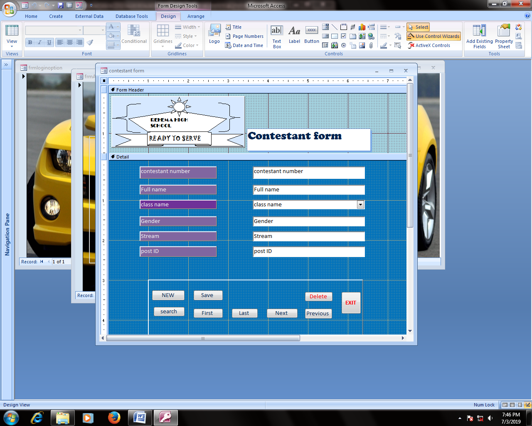

figure 26.5.1.1 contestant form

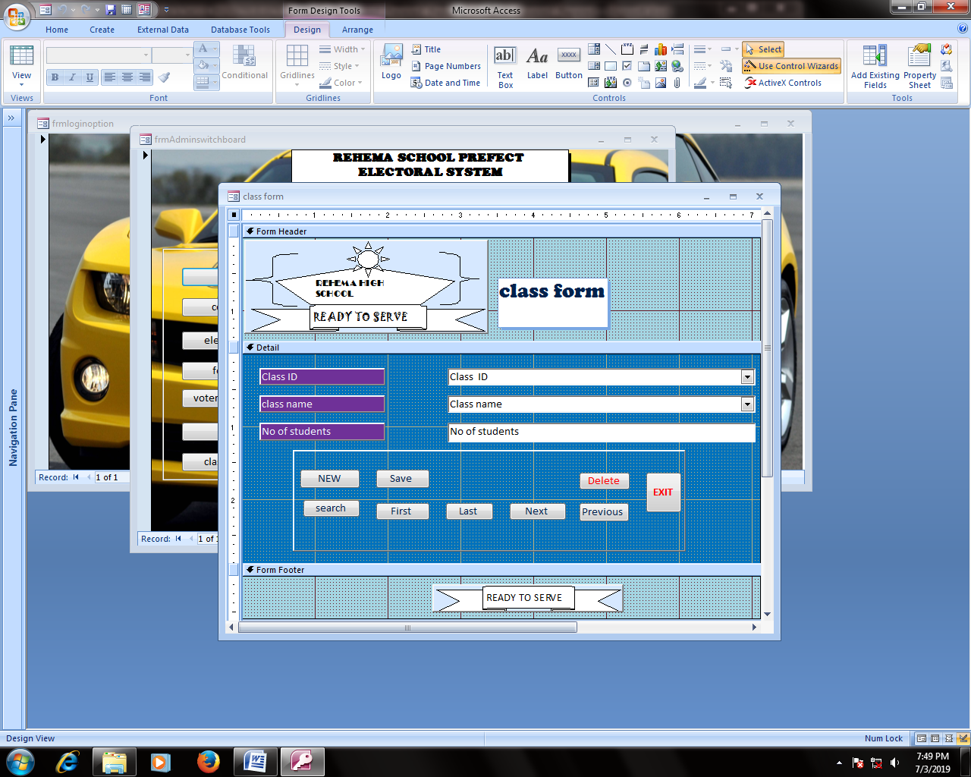

Figure 27.5.1.2class form

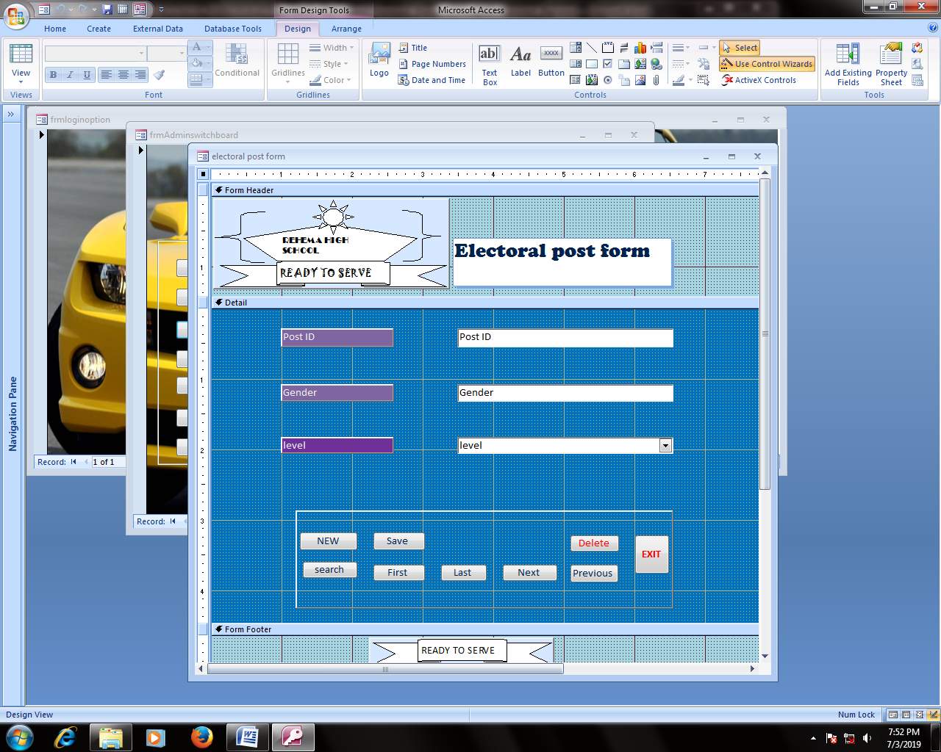

figure 28.5.1.3 electoral post form

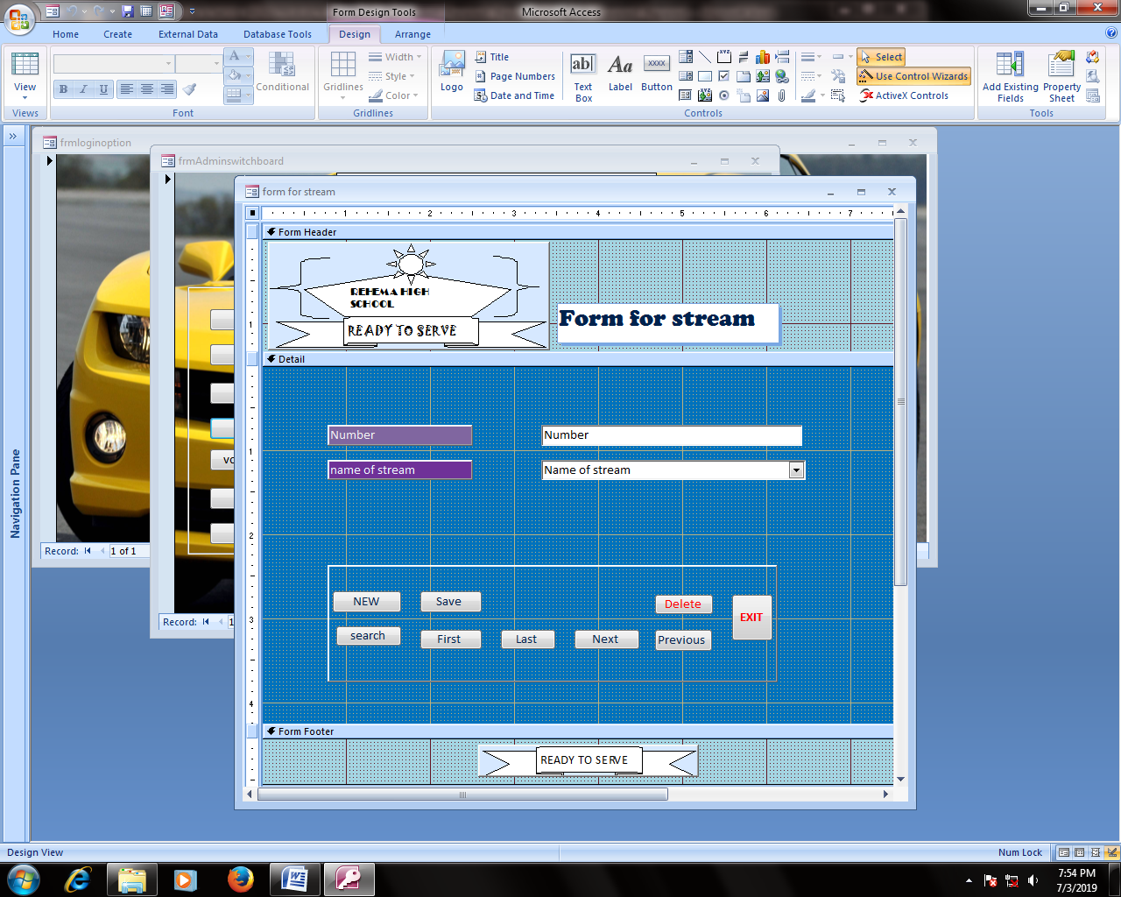

Figure 29.5.1.4 form for streams

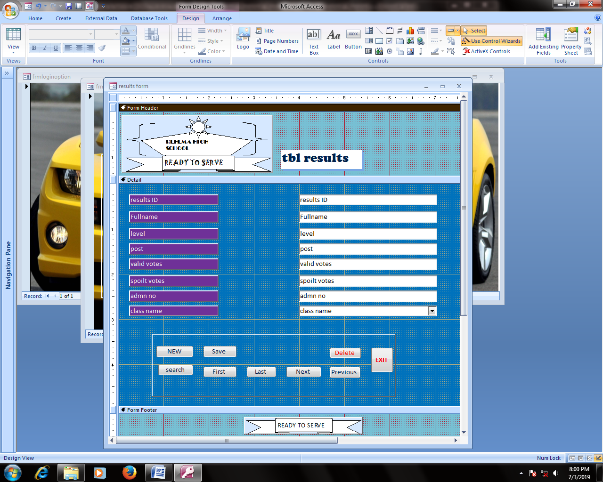

figure 30.5.1.5results form

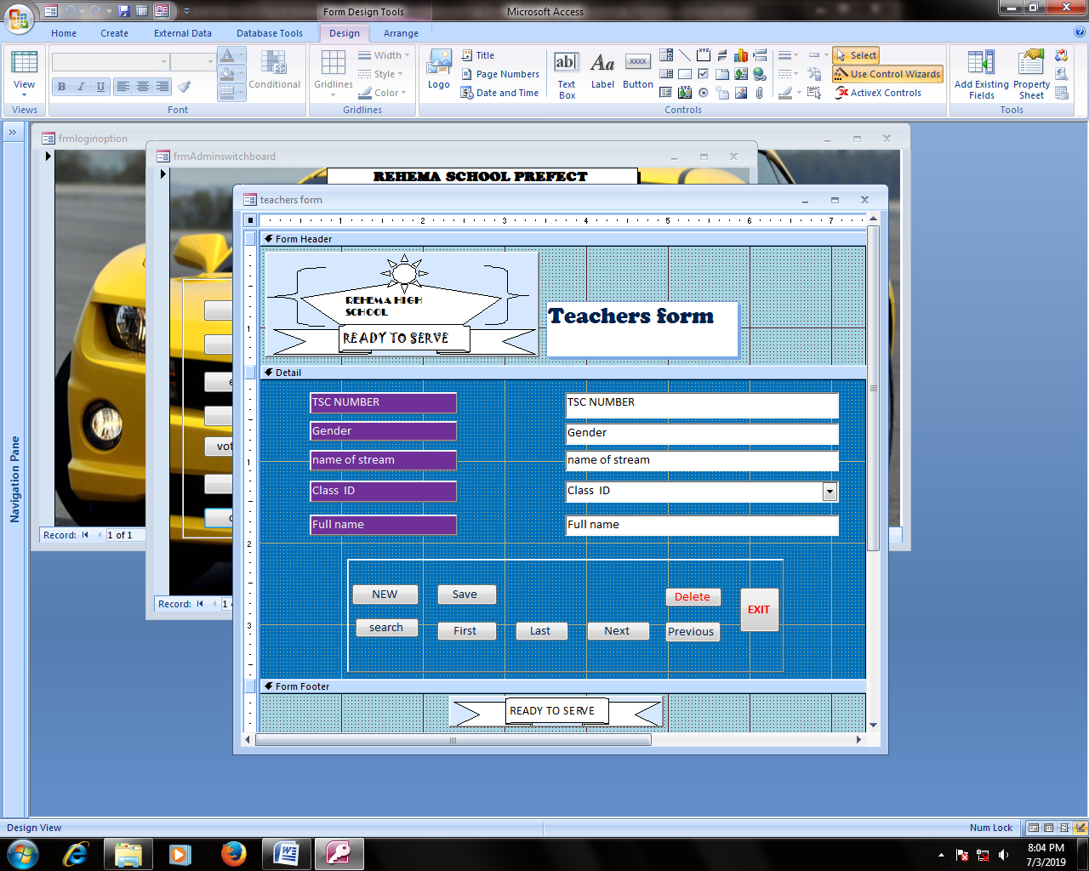

Figure 31.5.1.6 teachers form

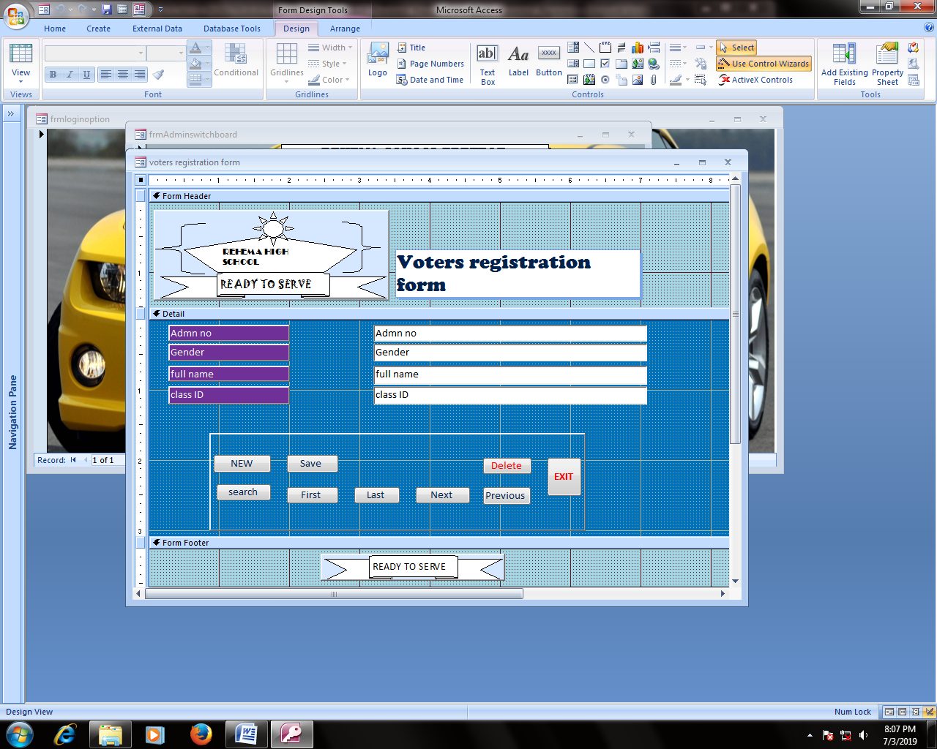

figure 32.5.1.7 voters registration form

## 5.2 TABLE DESIGN

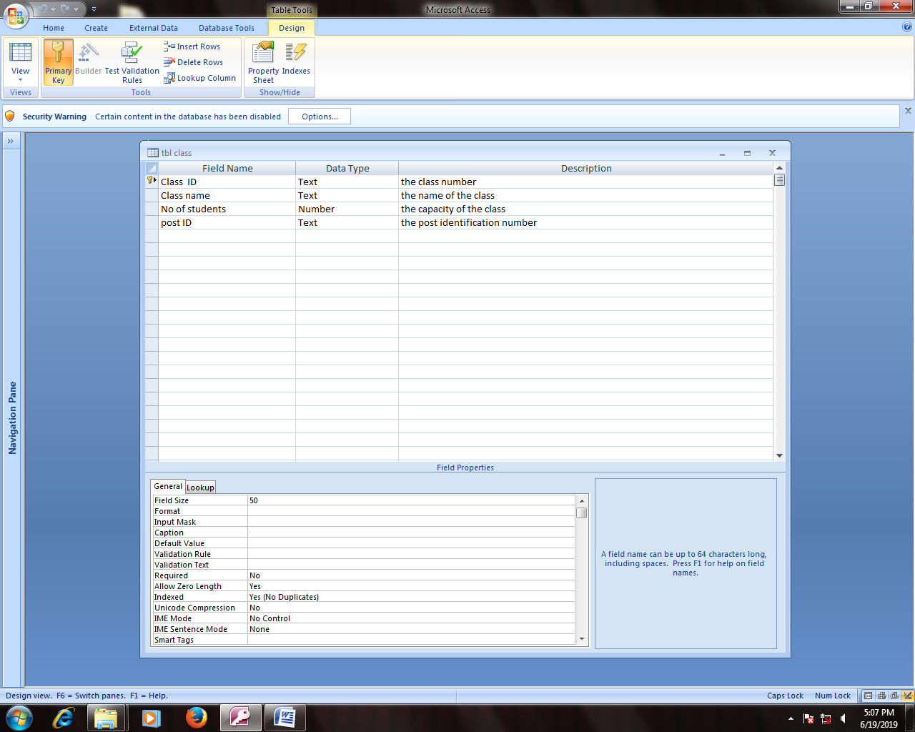

Figure 33.5.2.1 table class

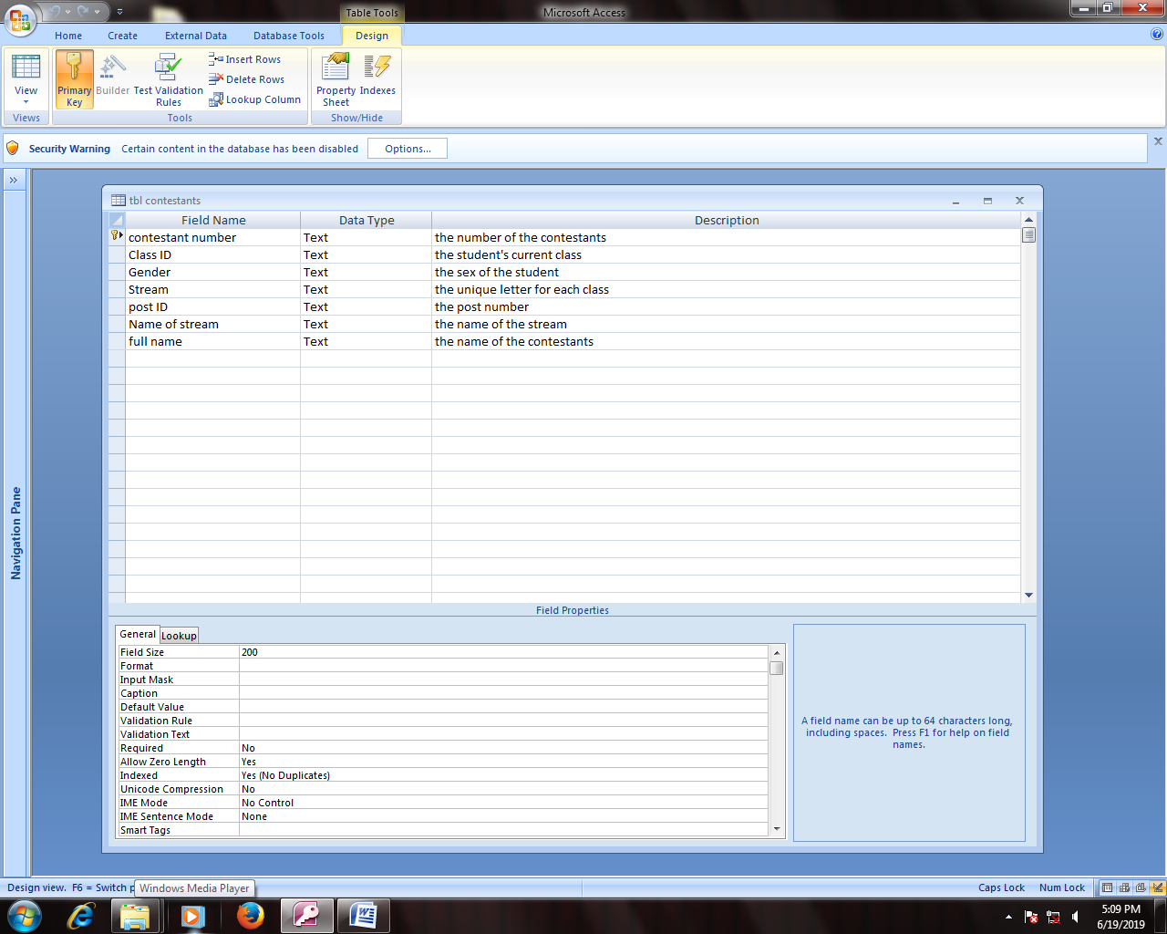

figure 34.5.2.2table contestant

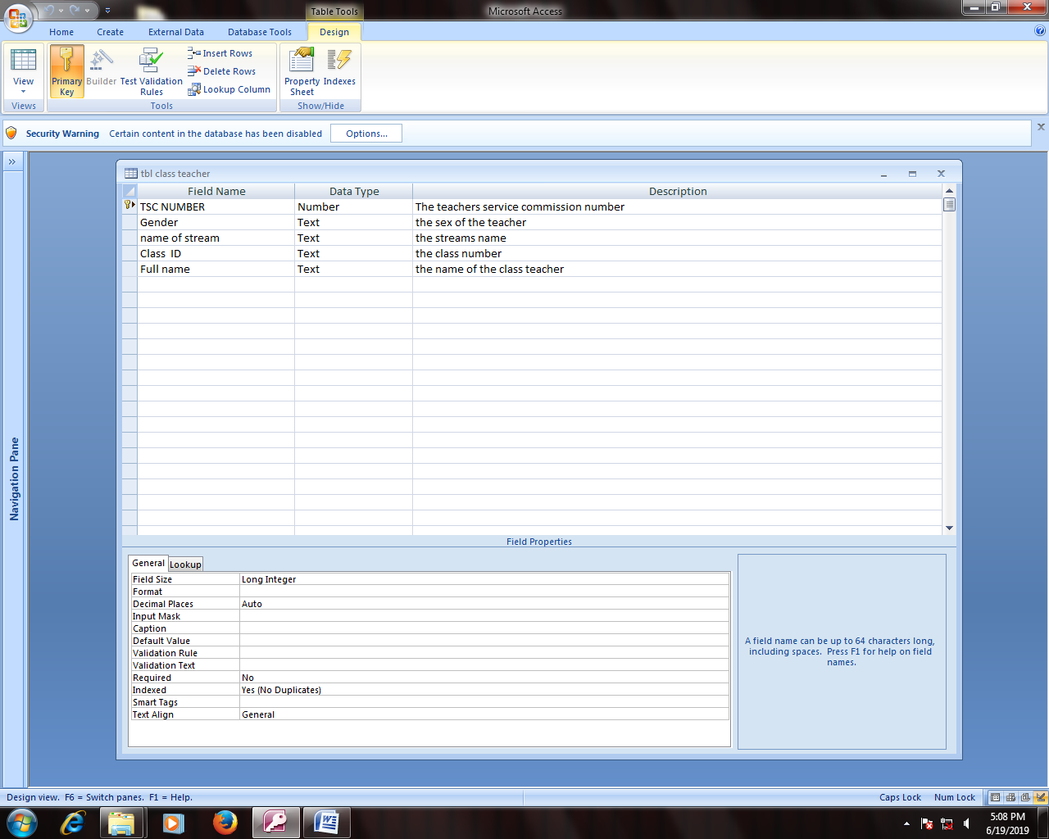

Figure 35.5.2.3 table class teacher

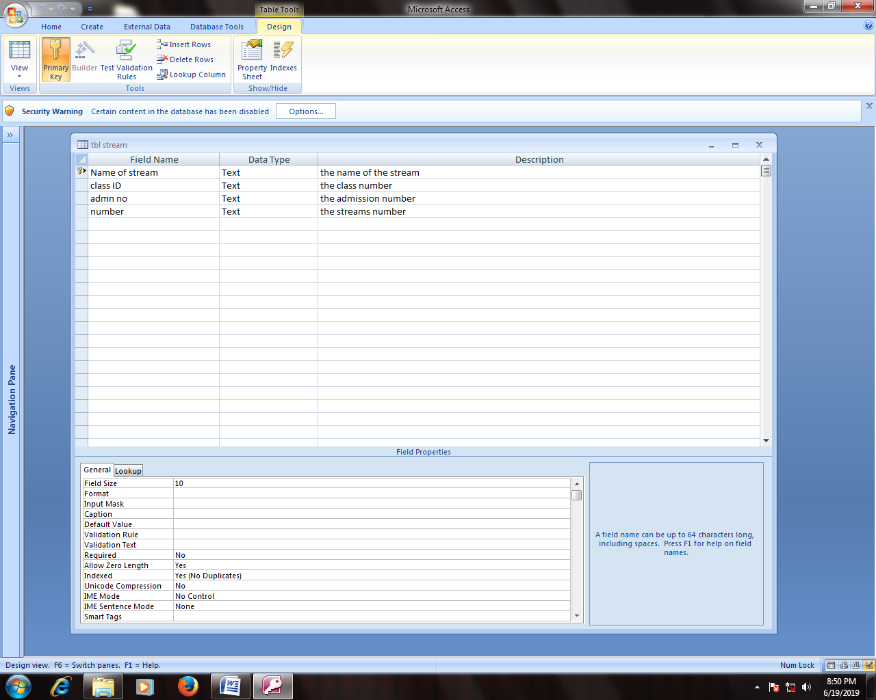

figure 36.5.2.4 table stream

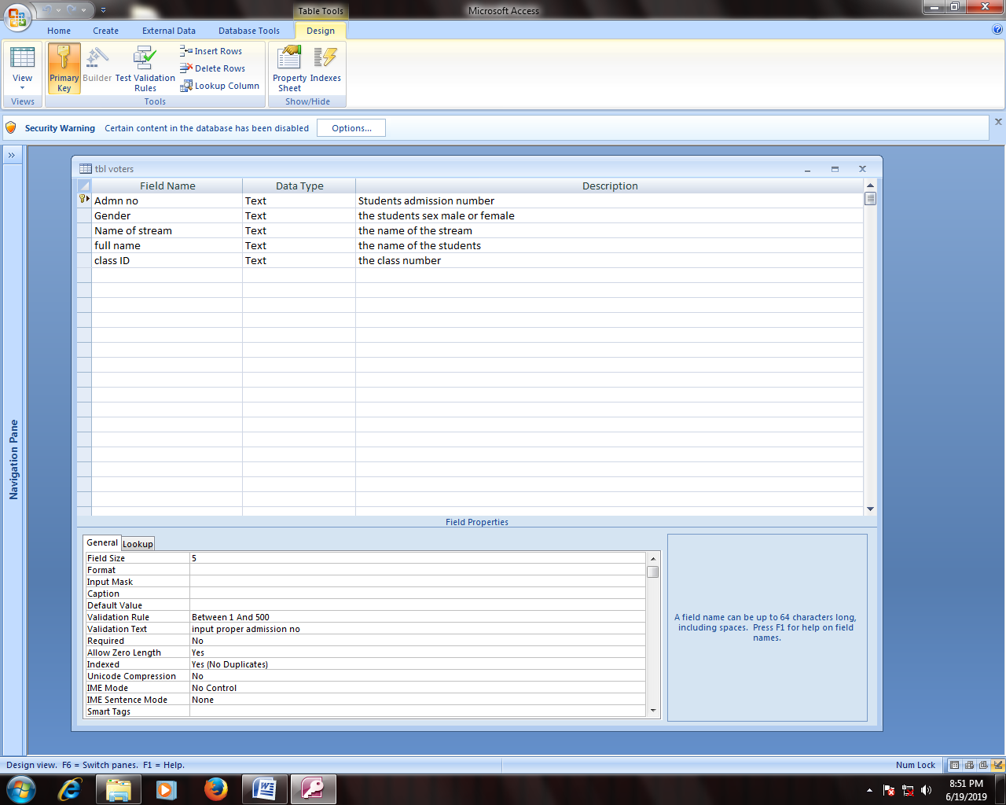

Figure 37.5.2.5 table voters

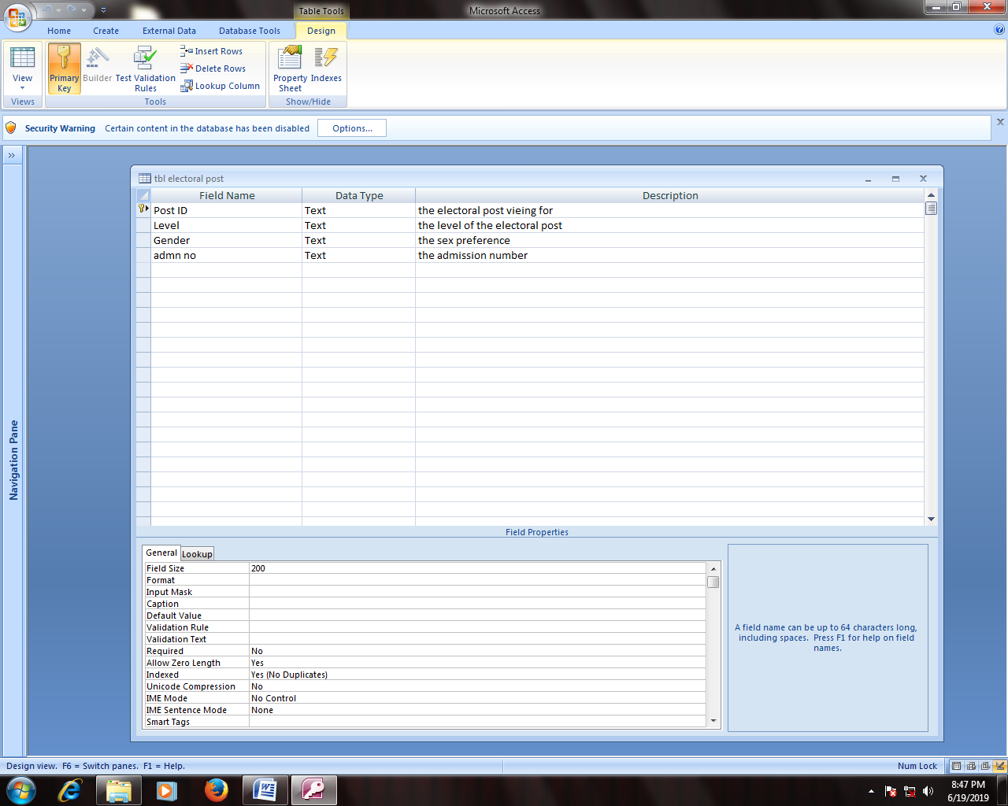

figure 38.5.2.6 table electoral post

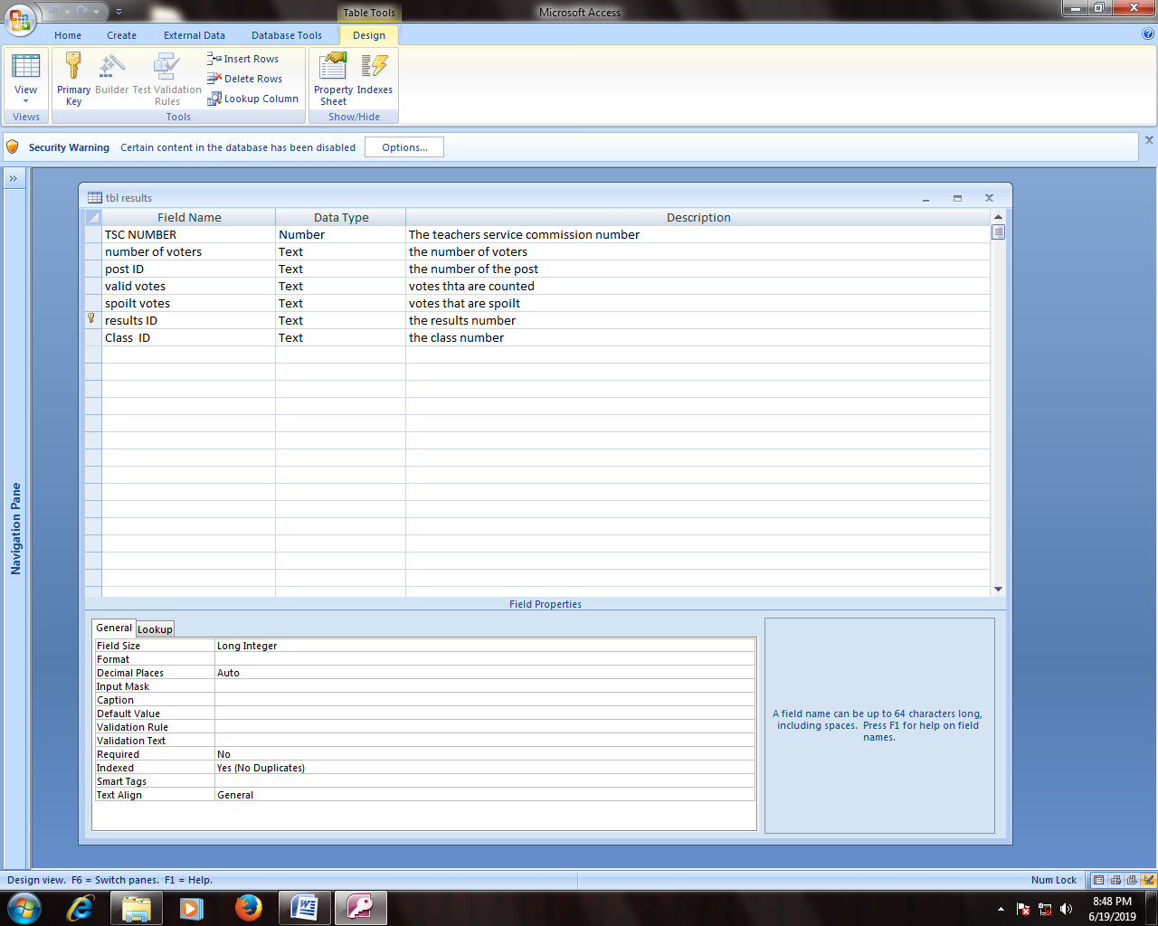

Figure 39.5.2.7 table results

## 5.3 QUERY DESIGN

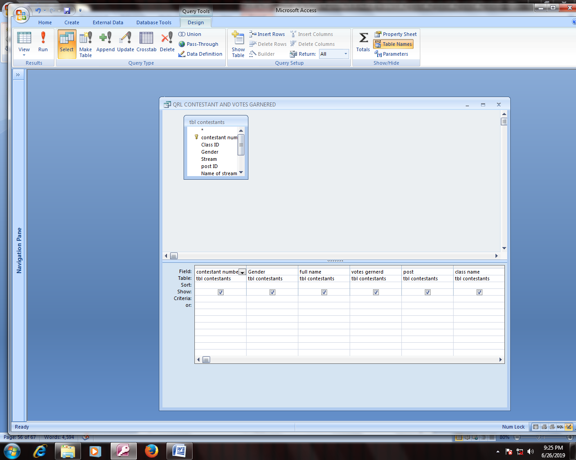

figure 40.5.3.1 Query contestant and votes garnered

SELECT [tbl contestants].[contestant number], [tbl contestants].Gender, [tbl contestants].[full name], [tbl contestants].[votes gernerd], [tbl contestants].post, [tbl contestants].[class name]

FROM [tbl contestants];

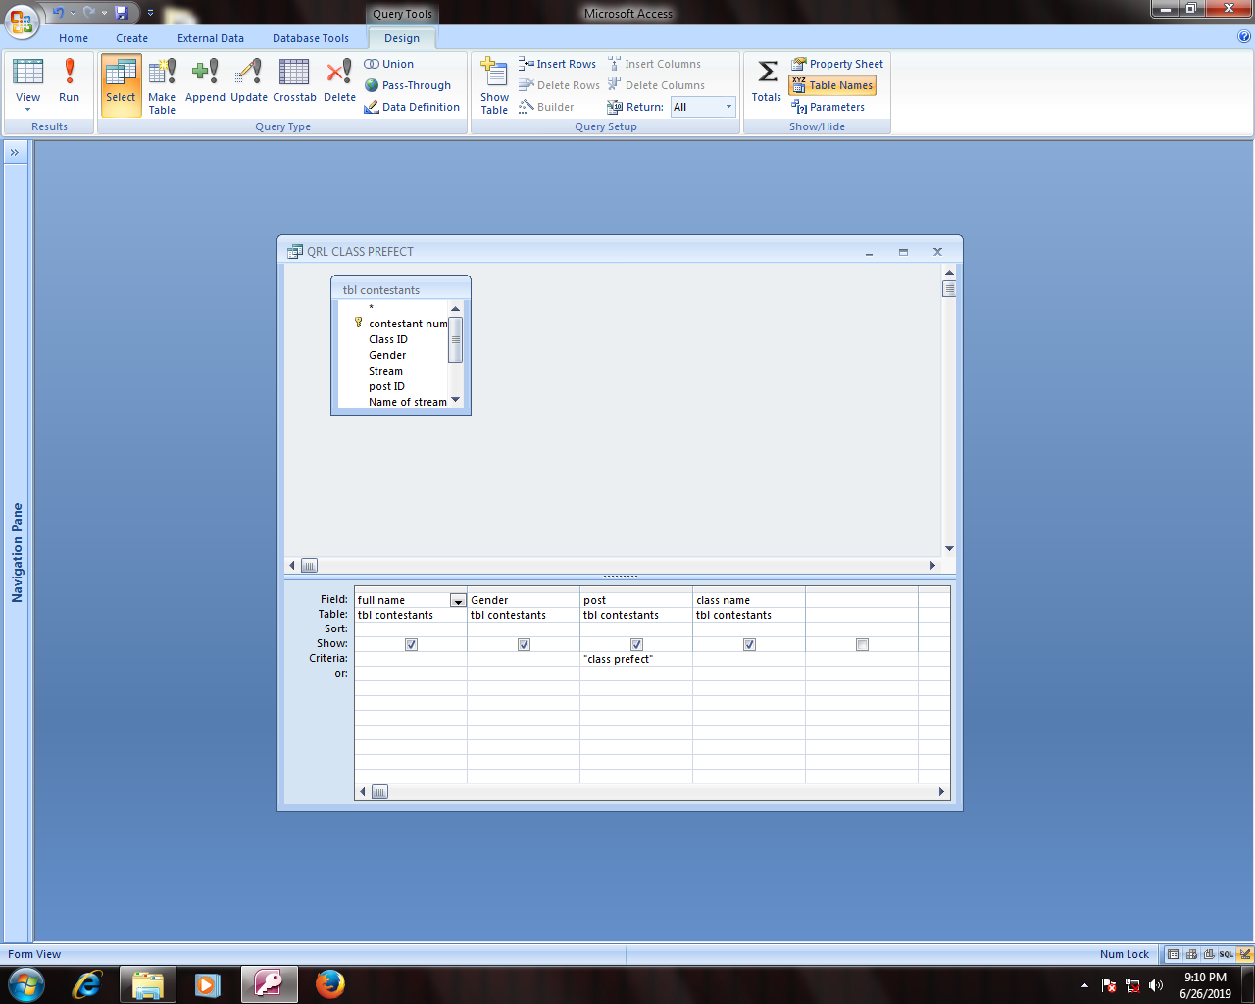

Figure 41.5.3.2 Query class prefect

SELECT [tbl contestants].[full name], [tbl contestants].Gender, [tbl contestants].post, [tbl contestants].[class name]

FROM [tbl contestants]

WHERE ((([tbl contestants].post)="class prefect"));

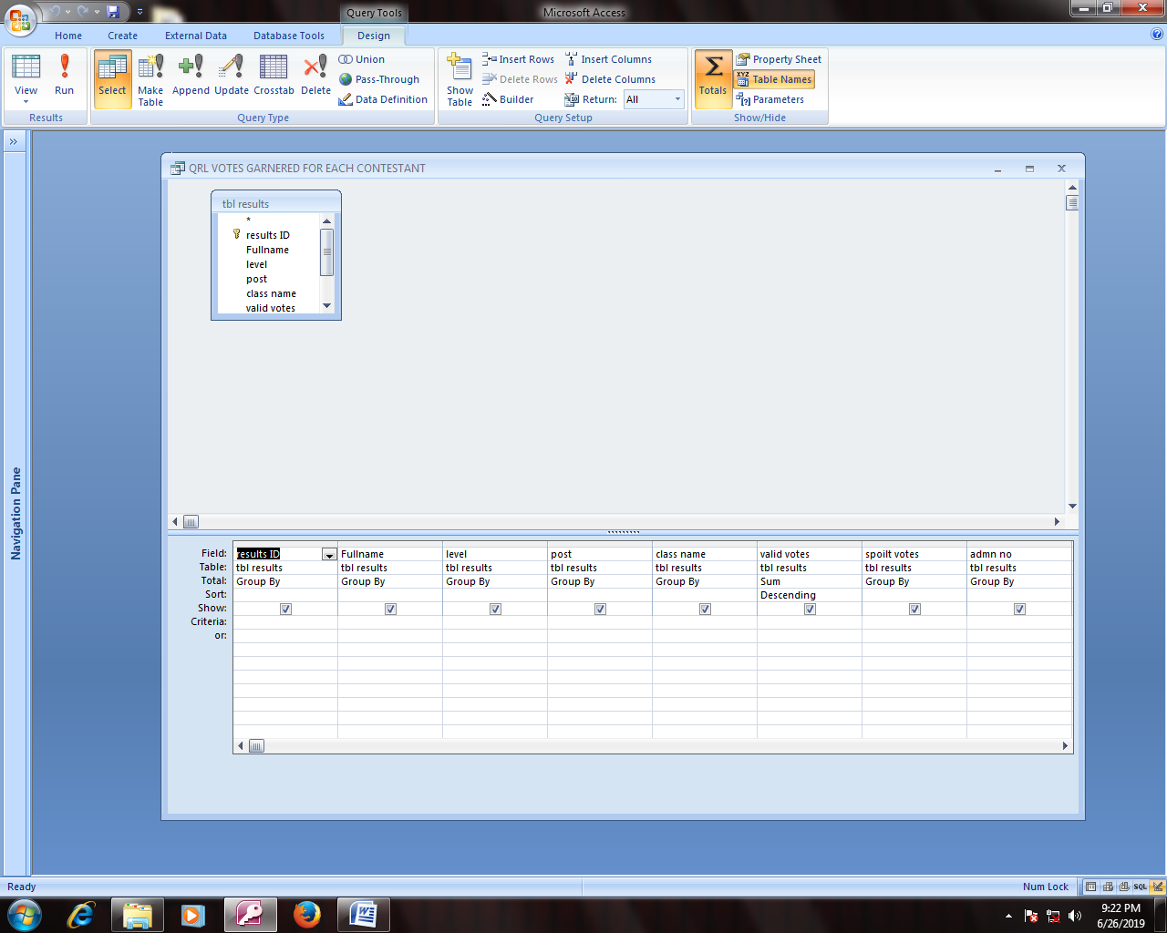

figure 42.5.3.3 Query votes garnered for each contestant

SELECT [tbl results].[results ID], [tbl results].Fullname, [tbl results].level, [tbl results].post, [tbl results].[class name], Sum([tbl results].[valid votes]) AS [SumOfvalid votes], [tbl results].[spoilt votes], [tbl results].[admn no]

FROM [tbl results]

GROUP BY [tbl results].[results ID], [tbl results].Fullname, [tbl results].level, [tbl results].post, [tbl results].[class name], [tbl results].[spoilt votes], [tbl results].[admn no]

ORDER BY Sum([tbl results].[valid votes]) DESC;

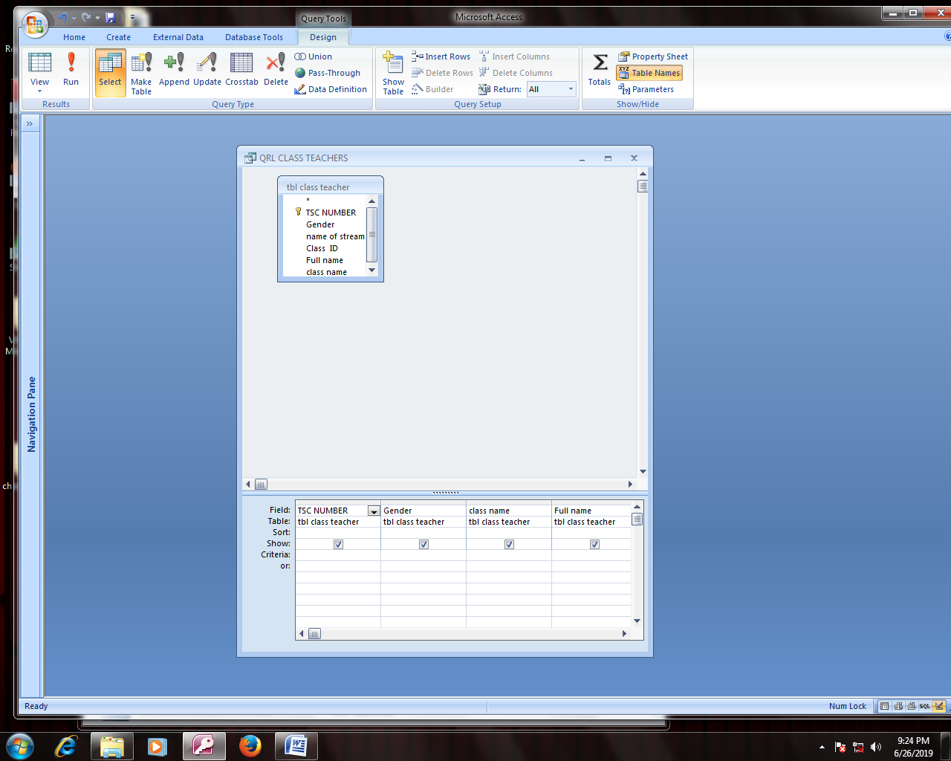

Figure 43.5.3.4 Query class teachers

SELECT [tbl class teacher].[TSC NUMBER], [tbl class teacher].Gender, [tbl class teacher].[class name], [tbl class teacher].[Full name]

FROM [tbl class teacher];

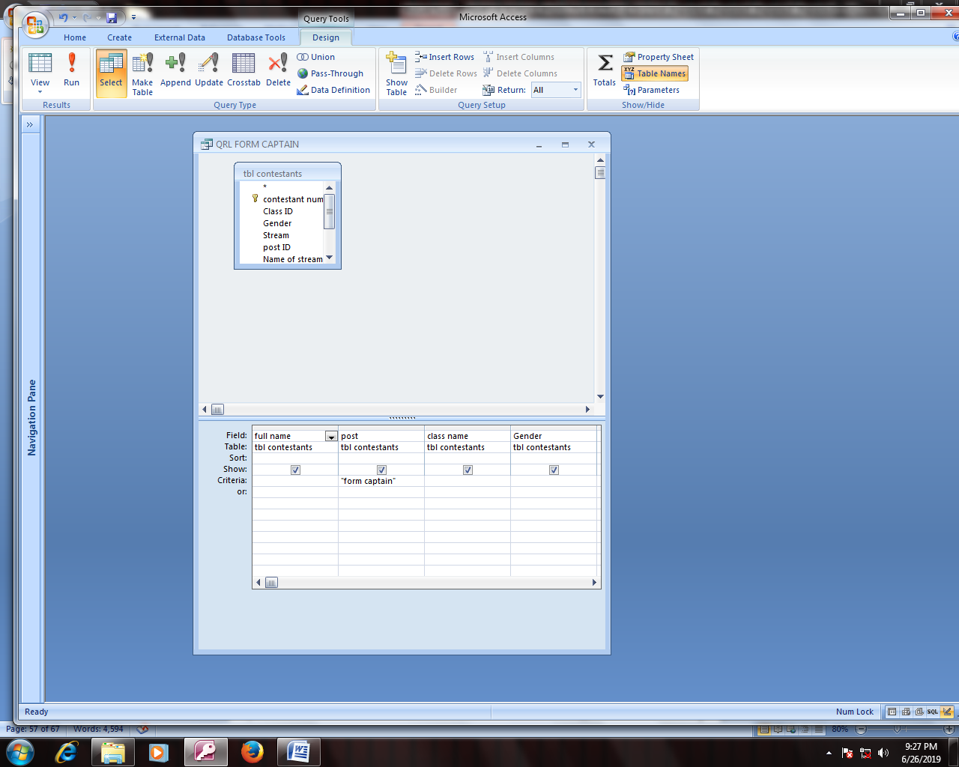

figure 44.5.3.5 Query form captain

SELECT [tbl contestants].[full name], [tbl contestants].post, [tbl contestants].[class name], [tbl contestants].Gender

FROM [tbl contestants]

WHERE ((([tbl contestants].post)="form captain"));

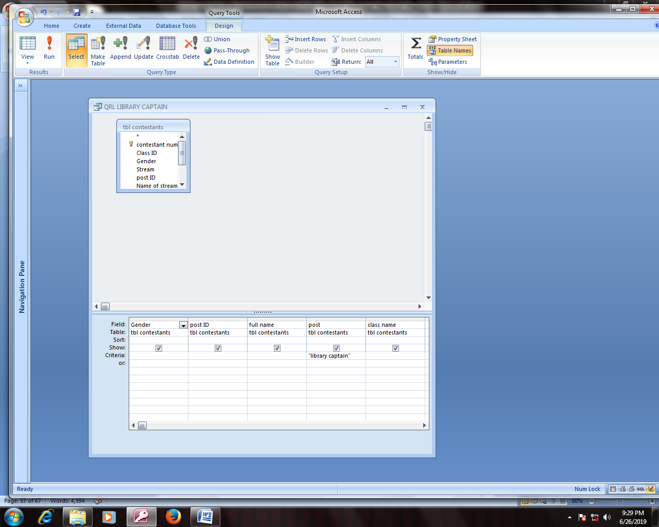

Figure 45.5.3.6 Query library captain

SELECT [tbl contestants].Gender, [tbl contestants].[post ID], [tbl contestants].[full name], [tbl contestants].post, [tbl contestants].[class name]

FROM [tbl contestants]

WHERE ((([tbl contestants].post)="library captain"));

## 5.4 REPORT DESIGN

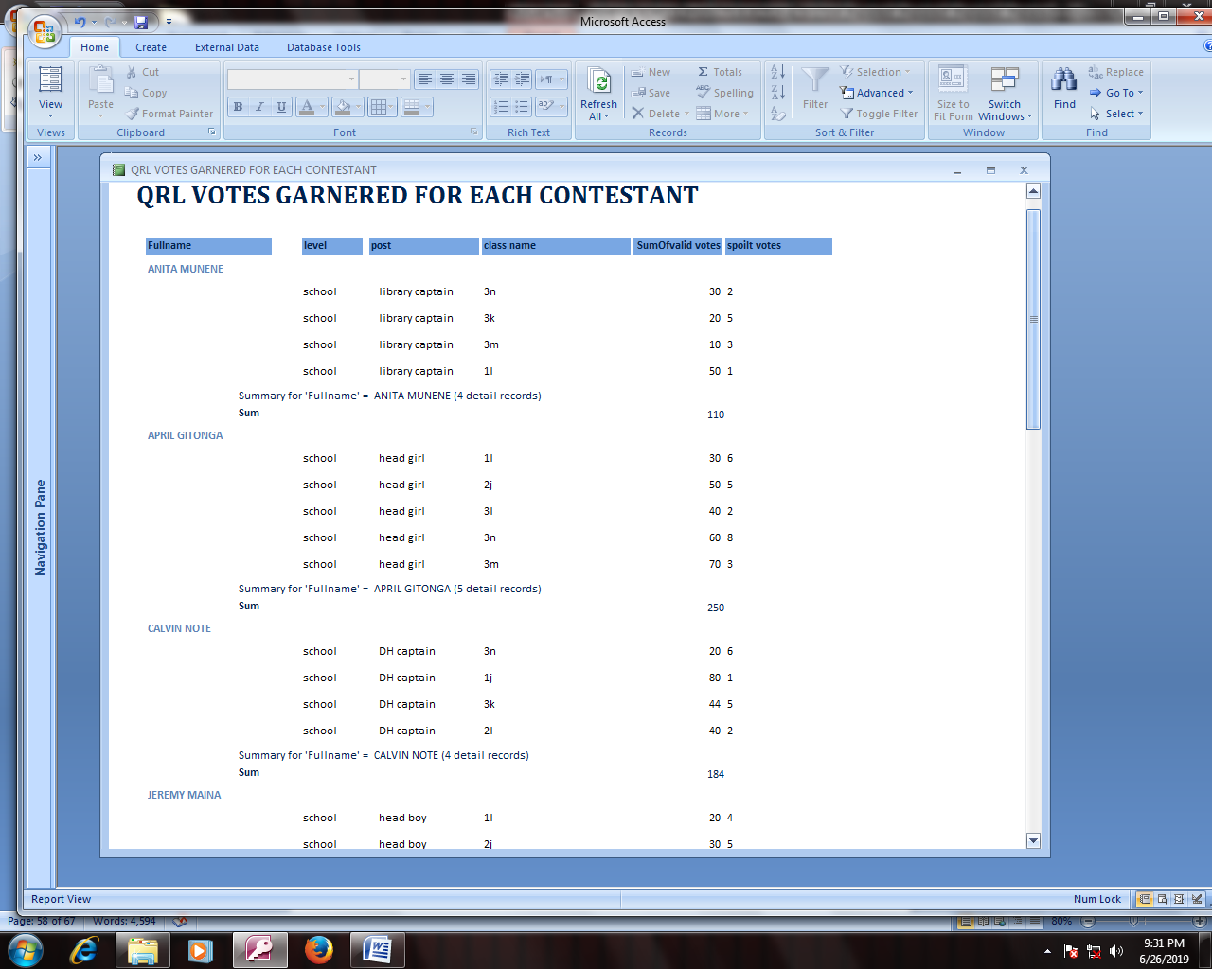

figure 46.5.4.1 REPORT FOR VOTES GARNERED FOR EACH CONTESTANT

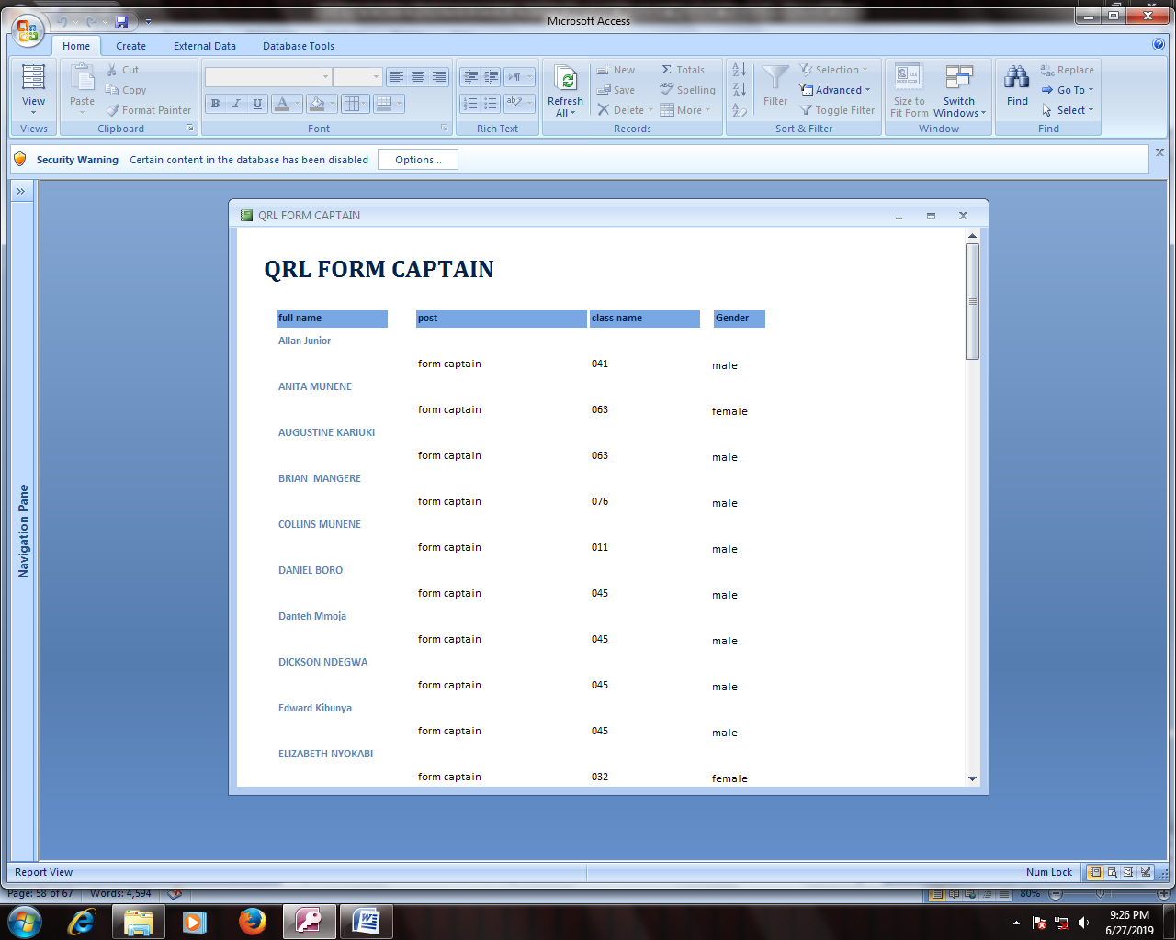Figure 47.5.4.2 REPORT FOR FORM CAPTAIN

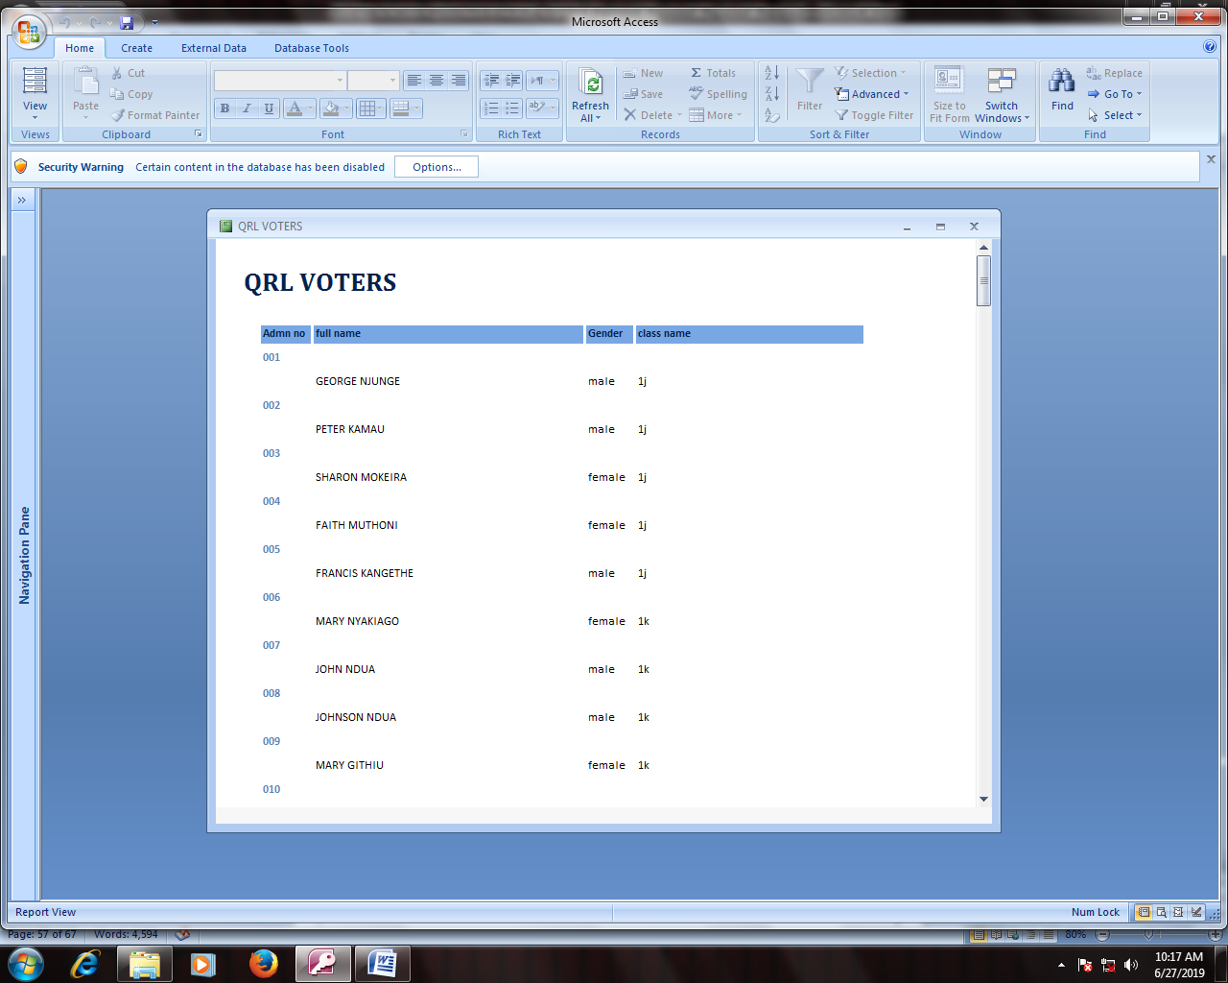

figure 48.5.4.3 VOTERS

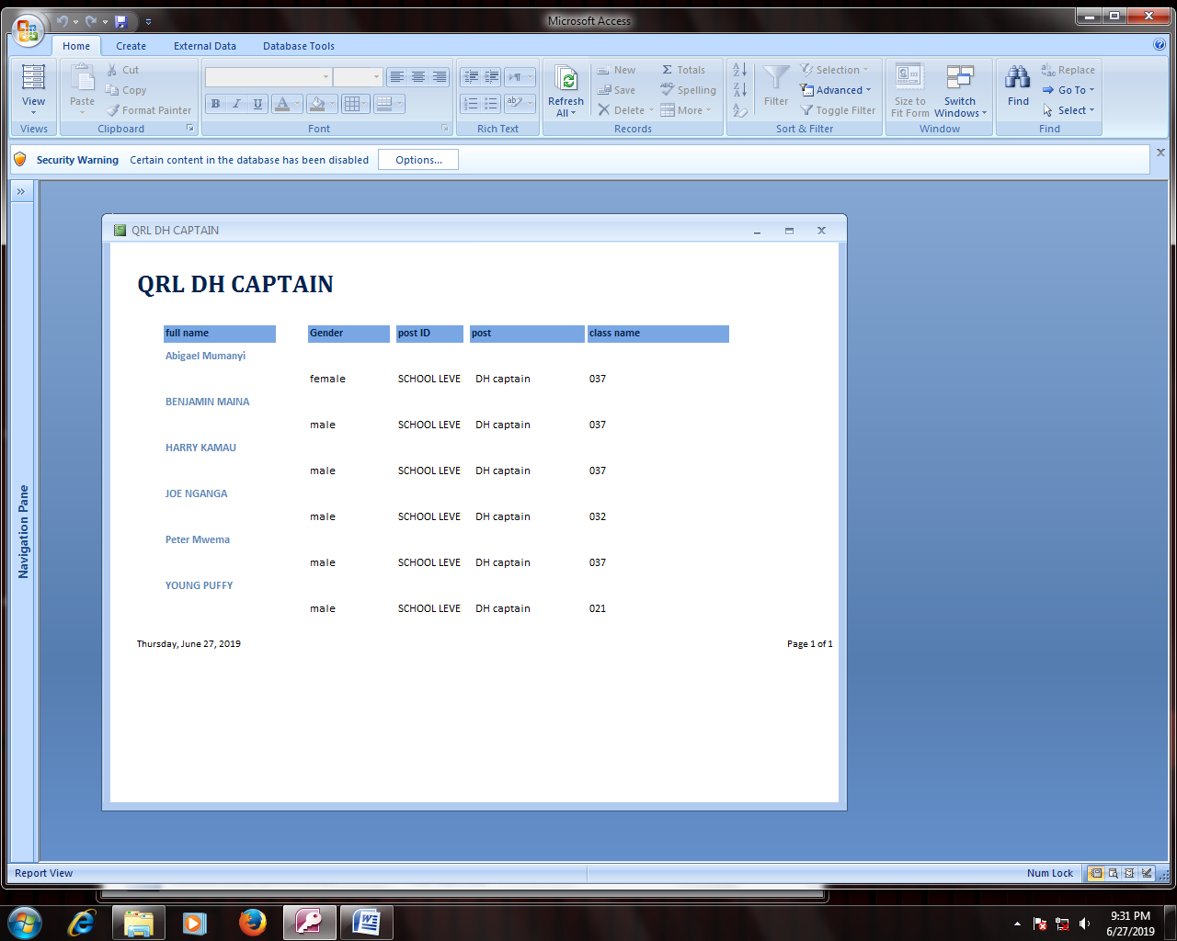

Figure 49.5.4.4 DH CAPTAIN

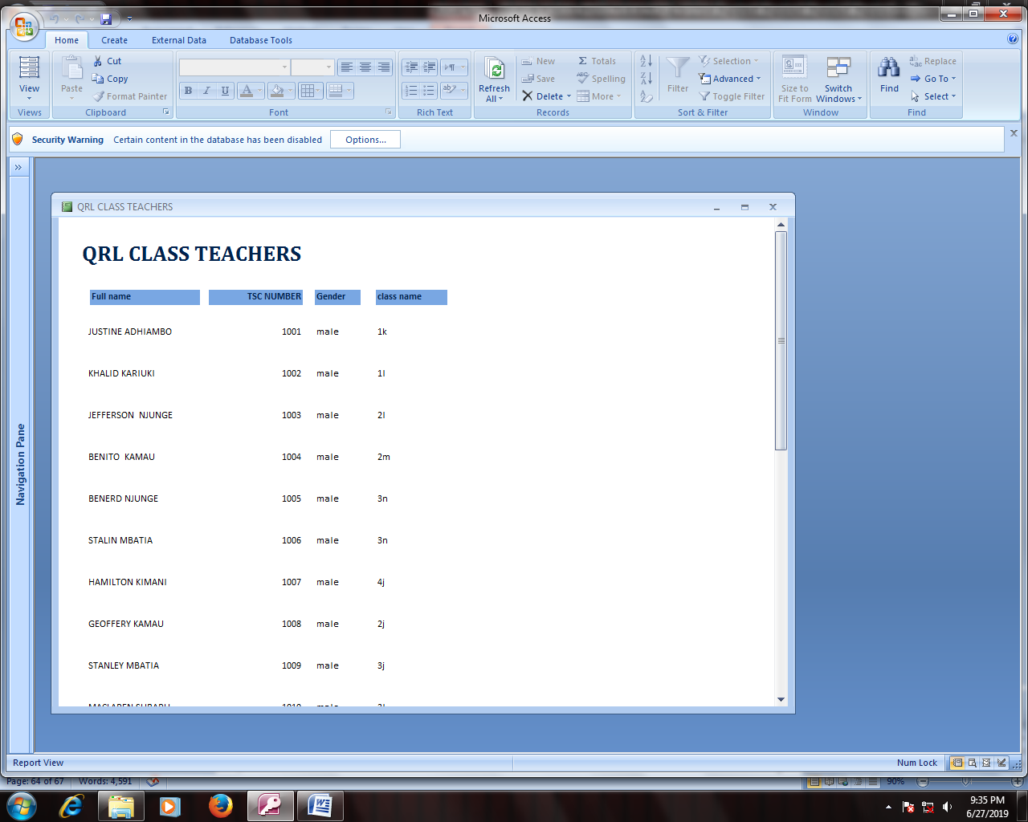

figure 50.5.4.5 CLASS TEACHERS

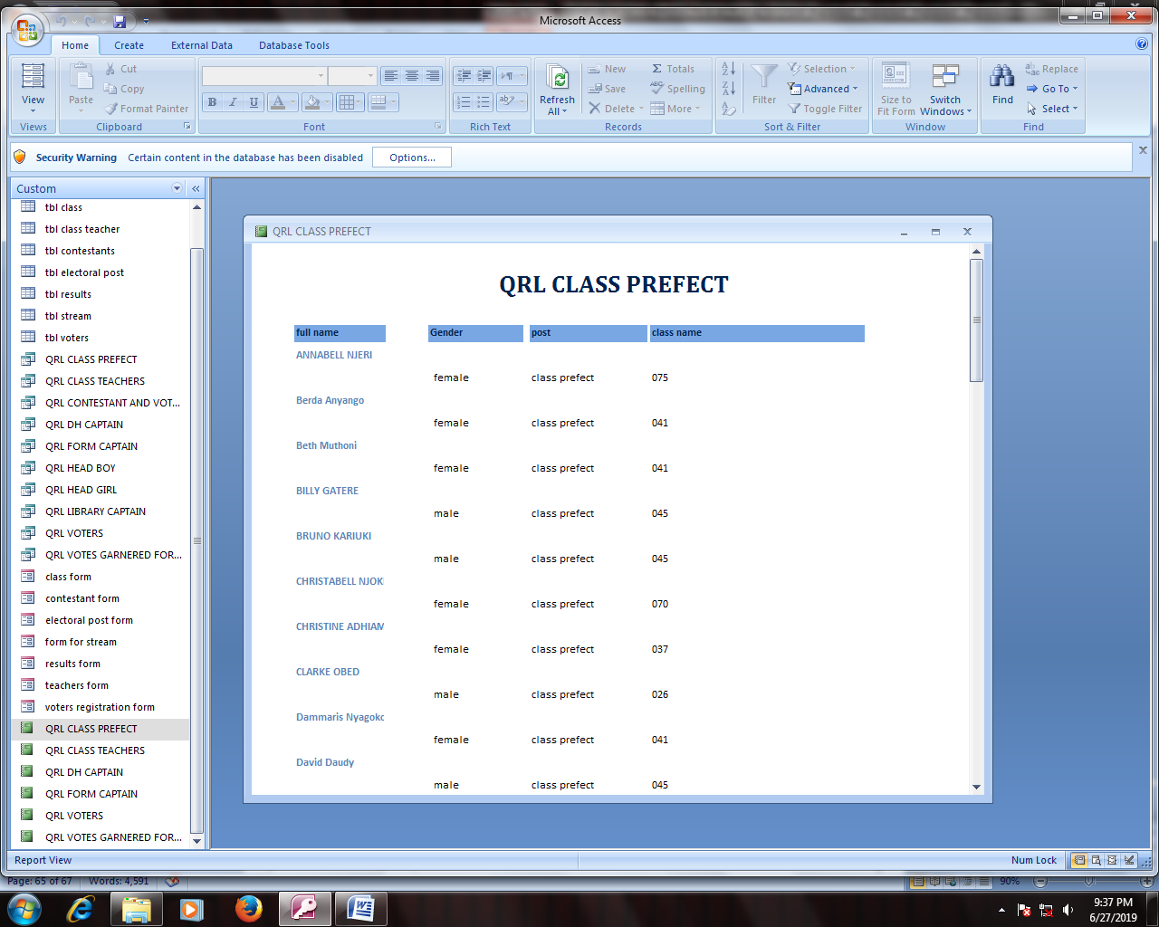

Figure 51.5.4.6 CLASS PREFECT

## 5.5 RELATIONSHIP DESIGN

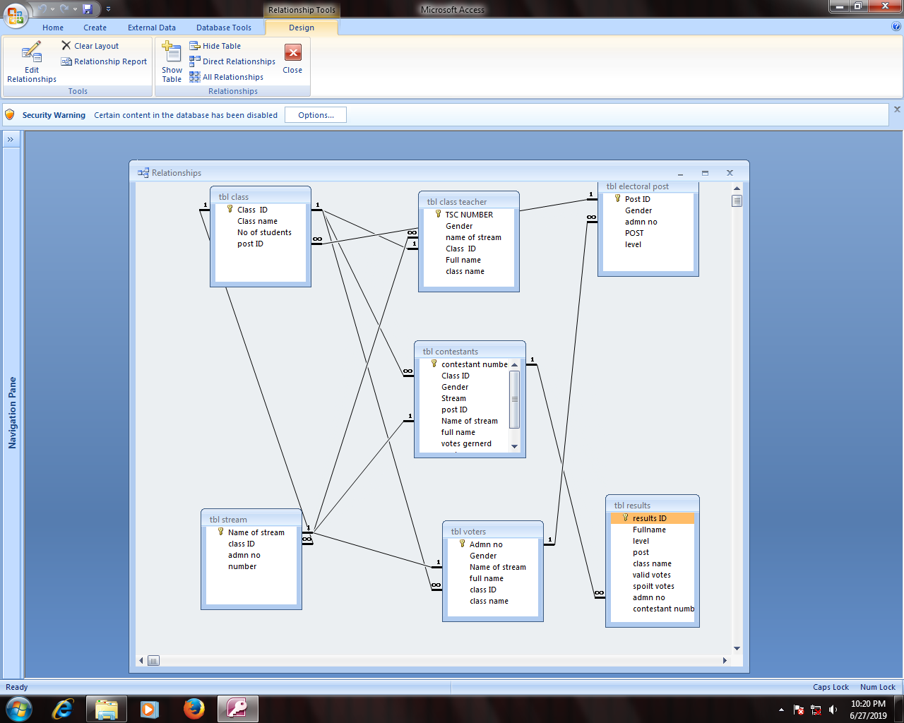figure 52.5.5.1 RELATIONSHIPS

# CHAPTER SIX

## 6.0 SYSTEM TESTING AND IMPLEMENTATION

## 6.1SYSTEM TESTING

The computer analyst tested this system using the following various means of testing as they follow:

* Dry running; It involves going through the program while still on paper before entering it in the program editor. Help detect most obvious syntax and logical errors.
* Using debugging utilities; after entering the program in the program editor, you can run debugging utilities during translation to detect syntax error in order to correct them before execution.
* Using test data; the programmer carries out trial runs of the new program. At each run, the programmer enters various data variations and extremes including data with error to test whether the system will grind to a halt.

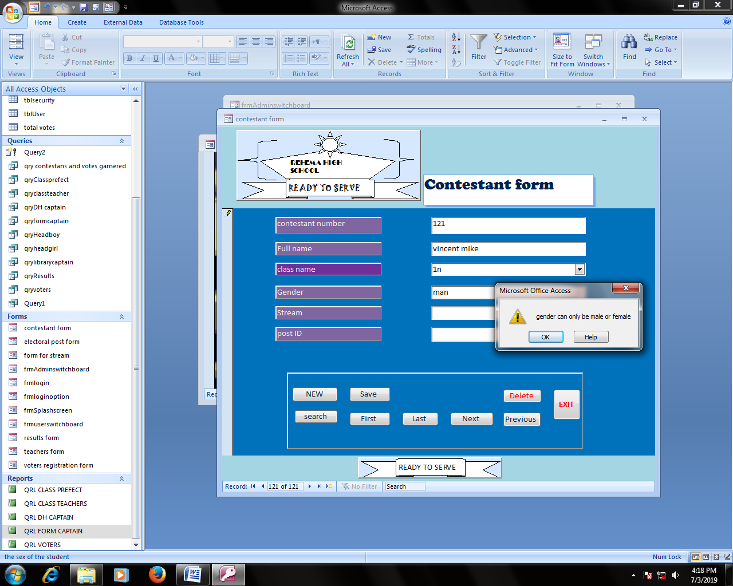

figure 53.6.1.1using test data method

## 6.2 OBJECTIVE OF TESTING

1. The aim is to check error in the system and to eliminate them for the system to run smoothly.
2. This is to ensure that the records stored in the system are safe from unauthorized personnel.
3. To check whether the proposed system is running better than the existing system.
4. To check the users friendly to the project.
5. To test the skill on operating this project.

## 6.3SYSTEM IMPLEMENTATION

This is the process of delivering the system from use in day to day operating environment for the user to start using it. During implementation the following areas are to be addressed. Include:

* File conversion
* Staff training
* Changeover strategies

### 6.3.1File conversion

This system may require a change in file format e.g. from manual to computerized.

1. Whether you need to install new application software.
2. There was need to create new database files are manual, electronic ones will have to be made.

### 6.3.2Staff training

Availability of appropriate documentation e.g. user manuals making training staff easy, quick and effective. System implementation can fail the staff are not trained well leading to great loss.

### 6.3.3Changeover strategies

This means to move from the old system and start using new system. This includes:

Parallel changeover

In this as both the old and new system run parallel to each other for some time until users have confidence in the new system then the old system is passed out. Its lower risk to rehema school operations and thorough testing of the new system are some of its advantages.

Old system

New system

## 6.4 SYSTEM SECURITY AND CONTROL MEASURES

1. The new system has put into action the following control measures to ensure data security:
   * + 1. Setting out privileged, modification levels and limitations to ensure that the data modification is only done in an official way.
       2. There are different users and administrators to the system.
       3. The software privacy is protected and cannot be duplicated with a copyright.
2. The system is not accessible to residents for continuous assured security:

* Always scan the computer against viruses before running the file.
* Always log out the system after use.
* Always lock the registration office securely whenever it is not in use.
* Obtain a UPS for the computer to regulate power entering into the system.
* To keep the system away from disastrous hazards e.g. Floods.
* To handle all hardware components of the system with maximum care.

# CHAPTER SEVEN

## 7.0SYSTEM REVIEW AND MAINTENANCE

## 7.1Rehema School Prefects Electoral System user manual

### 7.1.1The Installation requirements

For the User to install a program, the user must have the administrator’s privileges. He/she should follow the User guides;

* One should ensure the computer has a CD-ROM.
* One should insert the disk with the content/the system in the CD.
* One should ensure it meets all the specifications highlighted before.

### 7.1.2Steps of installation

1. Run the computer Microsoft Windows Operating System
2. Click on the start button.
3. Click on the “Control Panel”
4. On the options click on “Add or Remove User Accounts”. Click on “Add Program”.
5. Click on the CD and then select on the CD drive.
6. Open Rehema school prefect electoral system CD and then double click on the Rehema school prefects electoral system.
7. Rehema school prefects electoral system. exe.

The computer must have satisfied the Requirement Specifications

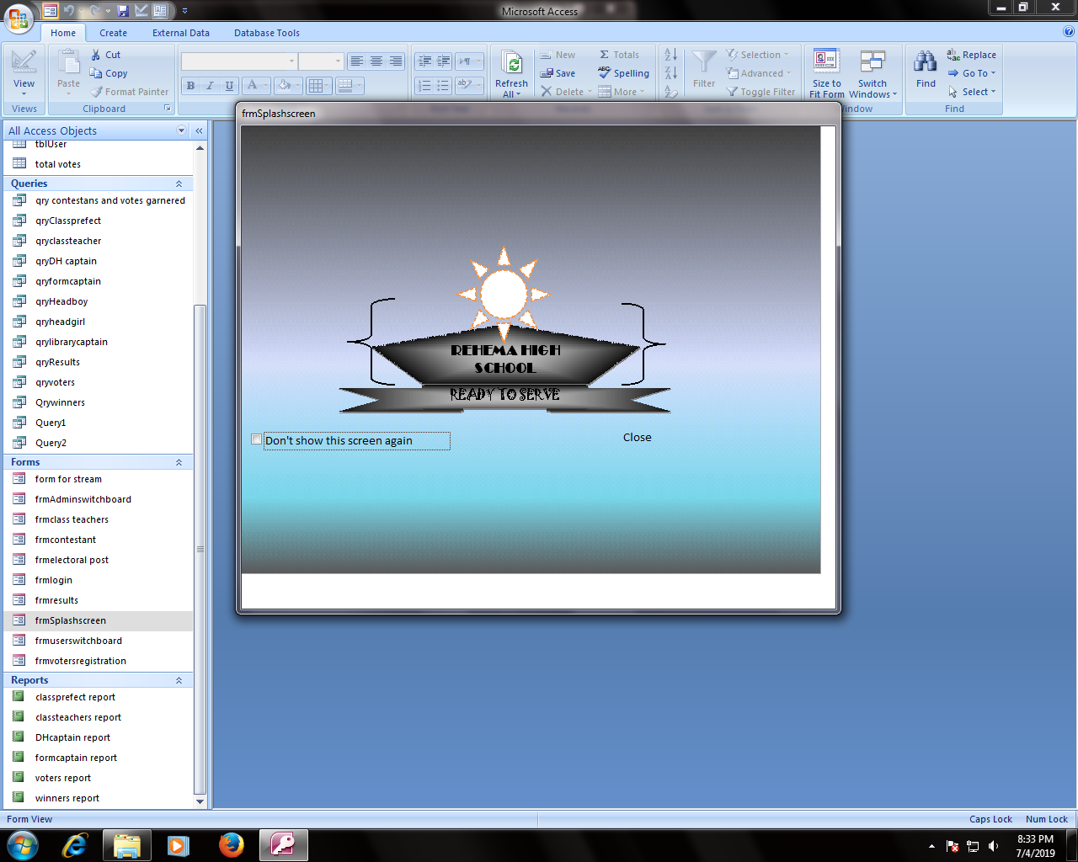

Figure 54.7.1.1the appearance of the sytem when loaded

## How to run the application program

* Insert the disc into your computer and follow the instructions on your screen. If you are prompted for an administrator password or confirmation, type the password or provide confirmation.

Many programs installed from CDs or DVDs launch an installation wizard for the program automatically. In these cases, the AutoPlay dialog box will appear and you can choose to run the wizard. For more information, see [AutoPlay: frequently asked questions](mshelp://windows/?id=7e1fe788-0747-4e00-895b-c3461b1ddd97).

If a program doesn't begin to install, check the information that came with the program. This information will likely provide instructions for installing the program manually. If you cannot access the information, you can also browse through the disc and open the program setup file, usually called Setup.exe or Install.exe. If your program was written for an earlier version of Windows, see [Make older programs run in this version of Windows.](mshelp://windows/?id=bf416877-c83f-4476-a3da-8ec98dcf5f10)

### 7.1.3Adding a new voter

1. Open the voter form to a Form view.
2. Click on the Command button “NEW”.
3. Type the data in the blank space.
4. Afterwards on the command button “Save”.

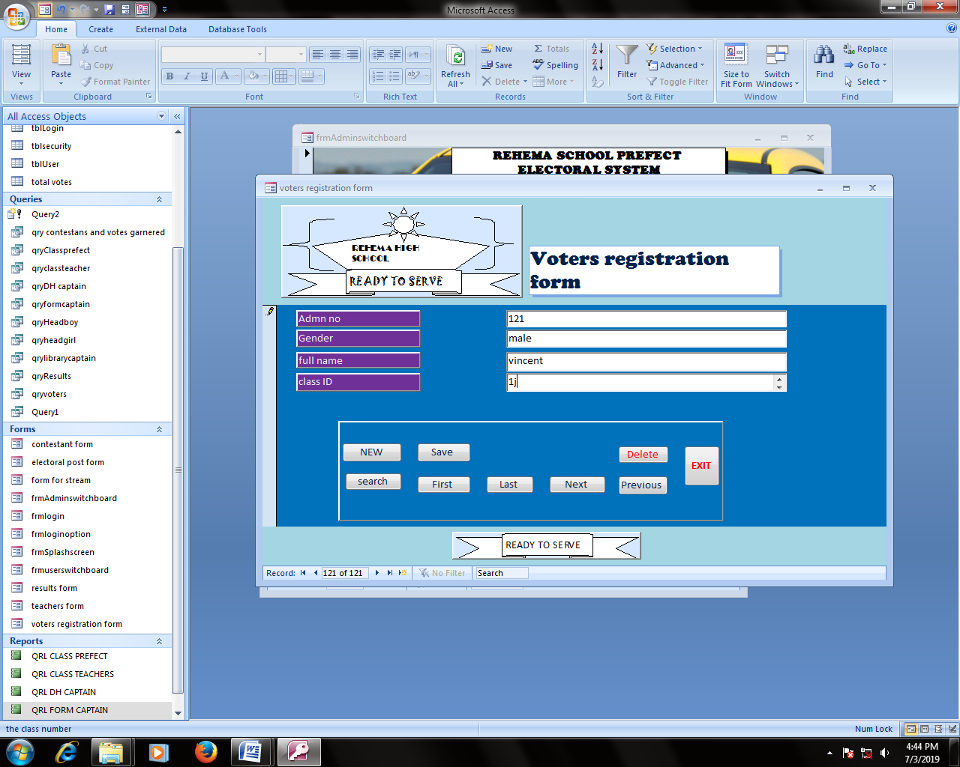figure 55.7.1.2 1adding a new voter

### 7.1.4Searching a voter

1. Open the voter Form in the Form view.
2. Click on the command button “Search”.
3. Enter the details of the voter to be searched, and then click Ok.

## 

Figure 56.7.1.3 searching for a voter

### 7.1.5 Deleting a voter

1. Open the form voter in a form view.
2. Click on the command button “Search”.
3. Enter the details of the voter.
4. After displaying click on the command button “Delete” which will delete the voter immediately.

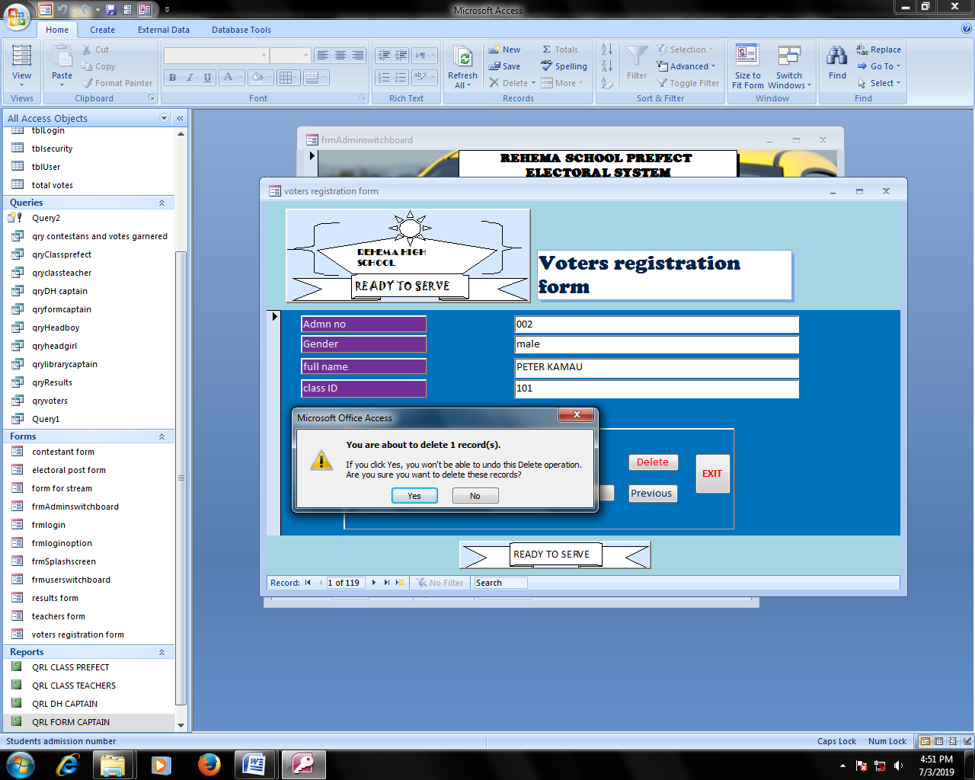

figure 57.7.1.4deleting a voter

### 7.1.6Steps on generating outputs

1. Click on the office button.
2. Click “Print”.
3. Select the form the user want to print the Ok.

### 7.1.7Ending the program

1. Save all changes made by the user.
2. Close all the forms, reports, queries or tables.
3. Open the form Login the click the command button “Cancel”.

## 7.2Recommendations

The new system received recommendations from all sectors of the organizations; This are the reasons why;

1. The system is highly adaptive.
2. The new system is simple to interpret.
3. The new system is long-lasting.
4. The new system maintains records.
5. The new system generates appropriate reports.

## 7.3Conclusion

Finally it will be true that the new system is better and more effective than the previous manual system. Though the initial set-up of the computerized system is costly, it will reduce registration expenses as mentioned early. The staff of Rehema school electoral system offices is more willing to embark on the use of this new system to produce good and accurate reports

## 7.4 Bibliography

The Bibliography below shows a list of Books and reference materials used in developing Rehema school electoral system.

1. Sarah E.H, Glen J.C: Microsoft Access 2000completeedition, MC Graw-Hill, 2000.
2. Kendal E.K, Kendal J.E.: System analysis and Design 5th Ed. Prentice-Hall (Now Pearson Education Inc). 2002.
3. Taylor G: GCSE Computer Studies, Macmillan Press Limited 1991.
4. Jeffery L.W. et el: System Analysis Design Methods McGraw-Hill 2000.
5. Williams BK; using information Technology: A practical introduction to computers and communications, / RWIN, 1995.
6. Saleemi N.A. System Theory and Management information systems, N.A. Saleemi Publishers, 1997 and 2000.
7. Gareth W. Student Handbook, ICT, Pearson Publishing 2000.
8. Microsoft Access 2000. North wind sample database 1999.

.

.

## 7.5APPENDICES

### 7.5.1Appendix 1

1. Flowchart – It is a diagrammatical representation of a program algorithm.
2. System - It is set of organized components which interact in a given environment and within a specified boundary to achieve a collective goal and objective that are emergent.
3. Debugging – Refers to the process of checking, detecting and correcting of errors in a program to ensure the expected output and objective is achieved.
4. Feasibility study – It is the study carried to establish effectiveness, reliability legal status and benefits of the system.

|  |  |  |  |
| --- | --- | --- | --- |
| Figure | Name | | Function |
|  | Rounded- corner Rectangle | | To represent a trigger event. |
|  | Arrow | | Denotes the direction of the logic flow in a program |
|  | Disk master file | | This shows a permanent file. |
|  | Parallelogram | | It represents a process. |
|  | Rectangle | | It represents a process. |
|  | Tagged-document | | This shows report being generated by the system. |
|  | Decision | | It indicates the decisions. |
|  | | Off-page connector | This connects from different processes in the same page. |

### 7.5.2Appendix 2

Table 9.7.5.1 diagrams used in the system